David Keith, Heather Bowlby, Freya Keyser, Julie Charbonneau
Variability in the recovery potential of globally exploited marine teleosts
Abstract
Marine fishes were once believed to be extremely resilient to the effects of fishing. However, this view has changed over time, partly due to the collapse and subsequent lack of recovery of several historically important stocks across the globe. This has raised questions about the underlying assumptions used in the management of these stocks and the impact of environmental factors on population dynamics. Despite extensive research exploring these challenges, few studies have explored the underlying demographic variability of harvested marine fishes using conservation biology and population ecology perspectives. Here we reconstructed the demographics of 77 stocks that are assessed in the north Atlantic and the northeast Pacific Oceans using life-tables. Demographic variability of these stocks was explored using metrics commonly used in conservation biology (i.e., population growth rates, doubling time, lifetime reproductive success, and generation time). λThe discrete rate of population growth is represented by λ, with values above, equal to and below 1 respectively signifying growth, stability and decline. Overall, the stocks analyzed show a latent capacity for population growth, with a median λ of 1.1, indicating a 10% increase in abundance per year, when the effect of fishing was excluded. When the impacts of fishing were accounted for the stock mean $λ$ dropped to 1.02 overall. However, individual $λ$, when accounting for fishing, were below 1 in 57% of the time. For many of the stocks population growth is driven by years with exceptionally high population growth rates. For most stocks, as abundance declined, lambdaλ tended to increase and become more variable WHAT IS THE RANGE OF VALUES?. These general patterns are highly variable among stocks and regions, with notable differences among Atlantic cod stocks in the northwest Atlantic. These stocks had few large recruitment events and evidence of positive density dependence (i.e., Allee effects or depensation) was relatively strong. The recovery potential was relatively high, with simulations indicating that 60 of the stocks would likely double in size within 20 years in the absence of fishing. Stocks with a low recovery potential were constrained to stocks with both a low median and λlow variability in $λ$. While most stocks exhibited a latent population growth capacity in the absence of fishing, regional and stock specific factors revealed that several stocks lacked this capacity, even in the absence of fishing. Knowledge of the underlying demographic parameters for a stock can be used to help sustainably manage the stock and can inform the development of rebuilding plans for stocks that have collapsed. Finally, we note that life history characteristics alone were a poor predictor of annual population growth or future recovery potential, with greater variability observed among stocks rather than among species with distinct regions associated with generally higher or generally lower vital rates.
So now I can try to do some tuning, both forwards and backwards, lets see what we get from that…

INTRODUCTION
Marine fishes were once believed to be inexhaustible and immune to the effects of fishing (McIntosh 1919; Nielsen 1976). However, striking collapses of once-prolific fisheries and delayed or failed recovery despite assessment-driven attempts (Myers et al. 1997; Frank and Brickman 2000; Hutchings 2000) have contradicted this perception. The assumption of resilience originated from early theoretical population dynamics modeling (e.g., Verhulst 1838) that culminated in the development of modern fisheries science, largely built around the concept of maximum sustainable yield (MSY, Ricker 1954; Schaefer 1954; Beverton and Holt 1957). Despite long standing concerns regarding the use of MSY (Larkin 1977; Finley 2019), its theoretical underpinning in equilibrium concepts and the associated idea that annual reproductive output and/or juvenile survival rates increase as abundance declines persisted along with the implication that harvesting activity will increase the per capita productivity of a stock (Schaefer 1954). Most modern assessments incorporate a stock-recruit function (Ricker 1954; Beverton and Holt 1957; Hilborn and Walters 1992; Subbey et al. 2014) making compensatory dynamics a foundational assumption about the life history of a species. Such fisheries assessments implicitly assume that lifetime reproductive rates in the absence of fishing would be expected to be greater than one (Hilborn and Walters 1992; MYERS et al. 1995), and that even heavily-exploited fish stocks retain a latent capacity for increase [maceRelationshipsCommonBiological1994]. Although MSY and equilibrium concepts are relatively straightforward intuitive, and provide a means of developing tractable mechanistic models, questions remain regarding their applicability (Larkin 1977; Finley 2019). There are concerns about whether they accurately reflect the system being modeled [Hilborn and Walters (1992); paulyPrimaryProductionRequired1995; Worm et al. (2009)], particularly for species with markedly different life history characteristics [hilbornFisheriesInducedChangesGrowth2008].
Life history characteristics (e.g. longevity, maximum size, individual or population growth rate) are now considered indicative of a species’ compensatory capacity (Myers 2001; Rose et al. 2001; Winemiller 2005) and are increasingly used within data-limited assessment approaches to provide management advice (Martell and Froese 2013; Pedersen and Berg 2017). Ecological theory suggests that “r-selected” fish species with small body size, characterized by numerous offspring, rapid growth, early maturity and short lifespans, should have greater compensatory capacity, greater resilience to environmental variability and, consequently, be better able to withstand fishing pressure (Law 2000; Kindsvater et al. 2016). Conversely, “K-selected” species with life histories characterized by longer lifespans and later maturity, or those with lower per-capita reproductive output, are considered less resilient (Winemiller 2005). Furthermore, the life history traits of closely related species are anticipated to be more similar than those of distantly related species owing to a shared evolutionary history (Thorson 2020). This implies that there should be less heterogeneity in the productivity among stocks of a single species than among different species. Following this, forage fishes and low trophic species are thought to be more resilient, and to recover quickly from low abundance (Essington et al. 2006). This resilience should manifest as a high latent capacity for population growth in the absence of fishing, as well as substantial variability in realized population growth rates among years. However, it remains unclear if correlated and compounding ecological and environmental processes (e.g., climate change effects, predator-prey dynamics) can obscure the importance of life history on realized productivity. This raises concerns that evolutionary and life history characteristics may serve as a weak foundation for data-poor assessments in light of changing oceans.
Stock assessment data from commercially-harvested marine fishes provide a unique opportunity to explore demographic variability and realized compensatory responses. Focusing on species with a long stock assessment history means that their life history characteristics are likely to be well-known and that it is possible to quantify realized variability in survival and reproductive output while accounting for the impact of fishery removals. We based our analyses on 77 marine fish stocks from a database of age-specific data (Charbonneau and Keith 2022). By constructing life tables (i.e. age-specific estimates of survival and reproduction rates) from abundance-at-age and catch-at-age data, we calculated standard demographic metrics, including annual population growth rates, doubling time, lifetime reproductive success, and generation time (Caswell 2001). Comparing the strength and magnitude of variability in realized productivity among species with different life histories and among stocks of the same species yielded unexpected insights. Notably, we find considerable differences in recovery potential among the marine fish stocks included in the analysis. While most stocks show a latent capacity for growth when fishing effects are excluded, some fail to recover even in the absence of fishing. Additionally, there is considerable life history variability among stocks of the same species, indicating that reliance on life history characteristics alone is a poor predictor of recovery potential.These results have implications for sustainable management of these exploited marine teleosts and could be used to inform future management actions for stocks that have collapsed. More broadly, our results challenge long-standing assumptionson the applicability of equilibrium theory, life history theory, and compensatory dynamics to explain expected productivity in fishes.

Methods

Data
These analyses used a data repository for 77 stocks from the Northeast Atlantic, Northwest Atlantic, and North Pacific; including stocks managed by the International Council for the Exploration of the Sea (ICES; 44), National Oceanic and Atmospheric Administration (NOAA; 25), and Fisheries and Oceans Canada (DFO, 8 stocks, Charbonneau and Keith 2022; Charbonneau et al. 2022). Data were available between 1947 and 2018, with an average length of 38.6 years (range 13 to 68 years). The assessed stocks represented 6 taxonomic orders, most representing Gadiformes (39 stocks), Pleuronectiformes (20 stocks) and Clupeiformes (11 stocks). The other three orders included relatively few stocks in the analysis, with 4 perciform stocks, 2 scombriform stocks, and 1 scorpaeniform stock. The majority of the data were for stocks from six species: Atlantic cod (Gadus morhua; 14 stocks), Atlantic herring (Clupea harengus; 9), haddock (Melanogrammus aeglefinus; 8), pollock (Pollachius virens; 5), Common sole (Solea solea; 5), and plaice (Pleuronectes platessa; 4).
The repository included age-specific estimates of abundance, weight, biomass, maturity, natural mortality, and fishery removals for each stock (Table 3). While uncertainty is inherent in assessment processes, each assessment is the basis for management advice following peer review, and thus, the underlying data represents the best available understanding of each stock's population dynamics.

Population Growth Rates
We used life table reconstructions to calculate survival-at-age and fecundity-at-age over time from the available data series. We applied the Euler-Lotka equation (Lotka 1907) to estimate the corresponding population growth rate ($λ$) in a given year. This allowed us to use information on births, deaths and maturity to describe each stock’s demographics relative to age and time using a tractable and consistent model despite variability among stock assessments. The discrete time Euler-Lotka equation was first proposed by Euler (subsequently published by Moser 1839) and is a special case of the continuous time demographic model first proposed by Lotka (Lotka 1907, 1918; Sharpe and Lotka 1911):
$1=\sum_{a=α}^{ω}{}λ_{y}^{-a}s_{y,a}f_{y,a}$
Where $a$ is the age, $α$ is the age at first reproduction, $ω$ is the maximum age, $λ$ is the discrete rate of population growth ($λ=e^{r}$), $s_{a}$ is the survivorship to age $a$, and $f_{a}$ is the fecundity of individuals of age $a$. This equation is solved for each year ($y$) with available data. The discrete-time Euler-Lotka equation is the characteristic polynomial of the Leslie Matrix, where $f_{0}$ is the fecundity of the first age class with mature individuals (Caswell 2001). We calculated the survivorship-at-age and fecundity-at-age using the available stock assessment data, which enabled $λ$ to be estimated. The assumption is that each stock represents a discrete population with individual dynamics.
When calculating survival and fecundity inputs, we considered the last observed age class to be the terminal age, beyond which there was no contribution to productivity. The first age class was age 1 for the majority of stocks (N = 42), and only 21 of the stocks had a first age of 2 (N = 10) or greater (N = rn.age.3.plus`) (Table X). For simplicity, we assumed survivorship to the first age class represented by the data to be 1, which results in a slight overestimate of productivity from the Euler-Lotka equation (Pardo et al. 2016). However, we tested back-calculating abundance for the earliest ages using the available time series of age-specific natural mortality rates for several stocks, and this resulted in negligible differences to the annual productivity estimates.

Fecundity-at-age
We parameterized fecundity as the number of offspring (recruits) produced by each female in each age class rather than as the number of eggs because the egg production by size, fertilization rates, and egg-to-age-0e survival rates are unknown. We first calculated an overall recruitment rate as the number of recruits produced per kilogram of spawning biomass $RPS_{y}$:
$$RPS_{y}=\frac{R_{y}}{SSB_{y-ra}}$$
Where $R_{y}$ is the number of individuals in the youngest age class available for a specific stock (hereafter referred to as recruits), and $SSB_{y-ra}$ is the total spawning stock biomass in year $y$, offset by the age of recruits ($ra$). For example, if the first age class in the abundance time series is 2 years, we assumed the recruits in 2010 were produced by the spawning stock biomass in 2008 ($SSB_{y-ra}$).
Then, we calculated the total number of recruits produced by each age class ($RPA_{y,a}$) by multiplying the spawner biomass in each age class $SSB_{\left(y-ra\right),a}$ by the number of recruits produced per kilogram of SSB:
$$RPA_{y,a}=SSB_{\left(y-ra\right),a}RPS_{y}$$
Fish are expected to have variability in reproductive success by age (ref, ref). However, we had to make the simplifying assumption that each kilogram of spawning biomass contributed the same to the total reproductive output, irrespective of age. We calculated the age-specific fecundity ($f_{y,a}$) as the number of offspring produced by each spawner in the stock. The number of spawners in year $y$ and age class $a$ ($NS_{y,a}$) is the proportion of mature individuals in each age class ($Mat_{y,a}$) multiplied by the number of individuals in each age class:
$$NS_{y,a}=Mat_{y,a}N_{y,a}$$
and annual fecundity becomes:
$$f_{y,a}=\frac{RPA_{y+1,a}}{NS_{\left(y-ra+1\right),a}}$$
Fecundity is offset by one year, as the recruits observed in year $y+1$ enter into the Euler-Lotka formulation in year $y$.

Survivorship-to-age
The number of animals surviving to each age (survivorship-to-age) depends on age-specific mortality rates (or, conversely, survival-at-age). Commercially exploited fishes experience fishing mortality ($F$) once they grow large enough to become vulnerable to the fishing gear (reference). Fishing and natural mortality ($M$) together yield total mortality ($Z$), affecting each age class each year. Due to challenges with separability in typical stock assessment models, different assumptions are made about natural mortality during stock assessments. For instance, mortality may be different for each age (Virtual Population Analysis models DOI: 10.1093/icesjms/39.2.175), allowed to vary over time and by age (Age structured model https://link.springer.com/book/10.1007/978-1-4615-3598-0), or held constant across ages (Statistical catch-at-age model). We did not explore these differences and used the estimates of natural mortality by age and year available in the data repository (representing outputs from each assessment), which we converted into an annual rate and for input into the Euler-Lotka equation.
The data also contained the number of fish harvested by the fishery each year and for each age. These can be divided by the assessed numbers at age to estimate fishing mortality in each year for each age.
$$F_{y,a}=\frac{Catch_{y,a}}{N_{y,a}}$$
Together, fishing mortality ($F_{y,a}$) and natural mortality ($M_{y,a}$) provide a total mortality estimate ($Z_{y,a}$) for each age in each year.
$$Z_{y,a}=F_{y,a}+M_{y,a}$$
Survival-at-age is simply:
ly,a=1=Zy,a ly,a=1-Zy,a
Then, we used the survival-at-age to calculate cumulative survivorship-to-age for input into the Euler-Lotka equation:
$$s_{y,a}=s_{y,\left(a-1\right)}×l_{y,\left(a-1\right)}$$
The availability of catch-at-age time series in the data repository meant that fishing mortality and natural mortality rates were separable. Given this method provides separate estimates of $F$ and $M$, we were able to calculate survival and theoretical population growth rates using the $M$ and fecundity ($λ_{F=0}$) estimates from the reconstruction. We recognize that the age structure in the underlying time series is still influenced by fishing pressure and that stocks vary in? size, so? $λ_{F=0}$ does not represent the maximum intrinsic rate of abundance increase [e.g., r_max; CITE]. However, our theoretical annual growth rates in the absence of fishing represent the productivity that the stock could have achieved in each specific year, if there had not been a fishery in that year.

Estimation
It is not straightforward to propagate observation error in each time series of calculated survivorship-to-age and fecundity-at-age. To ensure that variability did not accumulate into unreasonable predictions for annual stock productivity, we fit the Euler-Lotka model using an iterative minimization process, where predicted abundance in the following year:
$$N_{y+1}=λ_{y}N_{y}$$
was compared to the abundance estimate from the stock assessment for the corresponding year ($N_{y+1}$).
Where necessary, we adjusted the annual age-specific fecundity and natural mortality estimates until the $λ$ estimate from the Euler-Lotka equation resulted in an abundance time series estimate ($N_{y+1}$) that was within 5% of the abundance time series estimates output from the stock assessment (median difference was -0.1%). The adjustment was performed iteratively, with a step change (for most stocks, each step was a change of 0.5%, but 0.05% was used for some stocks) applied to the natural mortality estimates at each age first. If the estimated abundance was still not within 5% of the observed abundance estimate, then a step change in the fecundity was applied to each age. This procedure was repeated until the estimated abundance was within 5% of the observed abundance.
This approach ensured that our analyses reflected the same understanding of stock productivity, natural mortality, and fecundity as the current assessments by treating the abundance estimates in the data repository as observations rather than estimates. Although there are inherent limitations to treating stock assessment outputs as observed data (Brooks and Deroba 2015), these assessments represent the best available knowledge of the population dynamics of each stock.
Thus, the abundance time series is an appropriate benchmark against which to compare. The minimization procedure resulted in the final estimates of $λ$ being approximately 6.8% smaller than the initial estimates. Population growth rates from life table analyses typically decline when variability in the input parameters is accounted for [e.g., CITE Bowlby & Gibson 2020]. However, it is also possible that the removals series used in the stock assessments do not capture all sources of fishing mortality [e.g., unreported catch, bycatch and incidental mortality; CITE]. This would result in the estimates of $λ_{F=0}$ being lower than reality, necessitating slight reductions in fecundity and/or increases in natural mortality during the iterative minimization process.

Density Dependence
Life table analyses make no assumptions about population regulation and thus do not incorporate a density-dependent relationship between spawners and recruits (McAllister et al. 2001). However, our estimated productivity parameters could be explored for evidence of density dependence by modelling each stock’s annual population growth rate against relative stock size (expressed as a proportion of maximum abundance) in the same year. Density independence occurs when λ shows no relationship with abundance. Negative density dependence is observed when $λ$ it increases as abundance declines [CITE], which is the type of compensatory response described by typical spawner-recruit relationships (ref, ref). Positive density dependence occurs when λ increaseswith increasing abundance. This is also called an Allee effect when it occurs at low abundance (ref, ref). λ We evaluated both the realized productivity estimates ($λ_{F>0}$) and the theoretical productivity values, excluding the impact of fishing mortality ($λ_{F=0}$ ).
λF=0λF>0 λλλ
We used Generalized Additive Mixed Models (CITE MCGV and WOOD) to describe potential relationships, where the overall effect on lambda? and the effect for each stock was modelled as
$λ_{i,j}∼N\left(0,σ_{i,j}^{2}\right) E\left(λ_{i,j}\right)=μ_{i,j} log\left(μ_{i,j}\right)=Prop_{i}+Stock_{j}×Prop_{i} Stocks_{i,j}∼N\left(0,σ_{Stocks}^{2}\right)$
The interaction was modeled using the fs (factor smooth) basis in the mgcv package in R, which treats the smooth curves as random effects and is used when a factor has a large number of levels (CITE!). Although we explored various model formulations and alternative error distributions, all models had similar challenges in overcoming either the underlying non-normality or the heteroscedasticity of the data. Given these challenges, we do not use the model to determine the statistical significance of the trends. This approach was adopted to capture the global relationship and provide a relative metric of variability among the stocks.
For a reconstruction of time series as undertaken here, the maximum value of $λ$ is constrained at higher abundances because the maximum abundance is a known value (e.g., the maximum possible $λ$ at 50% of the maximum abundance is 2, at 25% it is 4, and at 100% it is 1). Conversely, the minimum value of $λ$ will be constrained at lower abundances (e.g., $λ$ must be $≥$ 1 when the stock is at its minimum observed abundance). As a result, at the maximum abundance $λ$ will be $≤$ 1, at the minimum abundance $λ$ will be $≥$ 1, and, on the natural scale, higher variability in $λ$ values at low abundances should be relatively common.

Recovery Potential
Numerous demographic parameters can be derived from the outputs of the life table reconstruction [CITE]. Here, we focus on three that are strongly linked to recovery potential: doubling time, lifetime reproductive success, and generation time (REF (Roff?). Comparing the median time frame over which abundance can double (i.e. doubling time) gives a good indication of relative productivity among species and stocks. We applied a Monte Carlo approach to draw from the observed distribution of fecundity and natural mortality in a projection simulation to estimate the doubling time for each stock. Lifetime reproductive success, also called net reproductive rate, describes the average number of female spawners produced by one female spawner throughout her lifetime. Values greater than 1 suggest a stock would increase, values less than 1 suggest a stock would decline, and a value of 1 indicates that the average female has produced sufficient offspring over their lifetime to only replace itself.
Generation time is an alternate indicator for the relative reproductive rate of a stock (REF), where shorter generation times are associated with faster population growth. Here, we calculated generation time for each cohort as the mean age of spawners that produced recruits [CITE]. Values of both the lifetime reproductive rate and generation time were derived for each complete cohort, which meant we could also evaluate changes in reproductive capacity over time for each stock. Additionally, we compared theoretical reproductive potential and generation times from life history characteristics alone ($F=0$) with those expected under current fishing mortality ($F>0$), as detailed in section 3.2.2.

Doubling Time
The annual fecundity and natural mortality values varied considerably for each stock. We used a simulated stock projection to account for this variability when evaluating recovery potential. For 1,000 simulations, we took a random sample of the annual values for fecundity and natural mortality, used the life table reconstruction to estimate $λ$, and calculated abundance in the following year. Abundance of each stock was projected over rn.sim.years` years, and the proportion of the simulations in which the stock size had doubled since year 1? was recorded each year. We considered stocks to have high recovery potential if 75% of simulated trajectories doubled, medium potential if 50-74% of simulations doubled, and low recovery potential if < 50% of simulated trajectories doubled, calculated at 10 and 20 years into the projection. For simplicity, we did not incorporate density-dependent effects (e.g., potential population decline as abundance exceeds carrying capacity) or any correlation (either temporally or between fecundity and natural mortality). Once a population had doubled, it was considered to have remained at that abundance or greater for the remainder of the projection. This means that the metric gave the earliest possible doubling time for each simulation, assuming no future fishing mortality.

Lifetime Reproductive Success
Lifetime reproductive success ($R_{0}$) was calculated for each cohort in which fecundity and natural mortality were available for complete cohorts (i.e., cohorts in which all available age classes are represented). For species with a long lifespan, this meant that lifetime reproductive success was more indicative of expectations from earlier in the exploitation history rather than more recent years.
It was calculated using only the natural mortality component ($F=0$) and the combined effect of natural mortality and fishing mortality ($F>0$), respectively. This provided an understanding of the reproductive potential from observed stock characteristics alone, and how it changed with fishing pressure. $R_{0}$ was calculated for each cohort as:
$$R_{0}=\sum_{x=α}^{ω}{}s_{x}f_{x}$$
This formulation ignores any contribution from a plus group, by assuming that the last observed age in the data represents the longevity of the cohort. This simplifying assumption will cause a slight negative bias in the values, given that the oldest sampled age class is typically younger than the theoretical longevity of a given species based on growth (CITE).

Generation Time
We defined generation time as the mean age of the spawners that produced the observed recruits in a cohort ($T_{G}$, Caswell 2001).
$$T_{G}=\frac{\sum_{x=α}^{ω}{}xs_{x}f_{x}}{\sum_{x=α}^{ω}{}s_{x}f_{x}}$$

Results

Population growth rates ($λ$)
The overall median population growth rate, when excluding the effects of fishing ($λ_{F=0}$), was 1.1 (+/- SD or interquartile), representing a latent capacity for population growth of 9.5% annually. Aggregating over years, the population with the highest median theoretical growth rate was Atlantic cod in the Irish Sea (median $λ_{F=0}$ = 1.44), and the lowest was pollock in the Gulf of Alaska (median $λ_{F=0}$ = 0.91) (Table 1). When the effects of fishing were accounted for, the overall median population growth rate ($λ_{F>0}$) dropped to 0.979 (+/- SD or interquartile) (Table 1), which would correspond to overfishing by 2.1% annually. The realized range of population growth rates was much narrower, as would be expected from managed stocks, where a typical goal is to maintain stock size at or above a specific biomass reference point (Marentette and Kronlund 2020). Median $λ_{F>0}$ was below 1 the majority of the time (i.e. in more than half of the years in the data) for 84.4% of the stocks, suggesting that stocks were being managed in a way that essentially eliminated their capacity for abundance increase in more than half of the years in the data. However, many of the populations included in our analysis experienced infrequent large recruitment events that resulted in high $λ_{F>0}$ estimates (Figures 1 and 2). For example, while the Gulf of Alaska pollock has the lowest median $λ_{F=0}$, it had a mean $λ_{F=0}$ of 1.11, and when the effects of fishing are included, this population had the $8^{th}$ highest mean $λ_{F>0}$ (1.08) (reference appropriate table–Table 1?). Consequently, the overall mean realized growth rate $λ_{F>0}$ for the populations in this analysis remained slightly greater than one. On average, population growth tended to compensate for declines in other years, maintaining a net positive overall productivity for most of these stocks.
Mean $λ_{F>0}$ was lower than the median for just 15 of the 77 populations, and the mean $λ_{F>0}$ was less than one for only 37 of the 77 populations.
The majority of the populations experiencing consistent declines, i.e. λF>0. (N = 12) were in the central or NW Atlantic, and included 5 of the 14 Atlantic cod (G. morhua) populations in this analysis.
There were regional and species-specific trends in both $λ_{F=0}$ areas $λ_{F>0}$. Haddock (M. aeglefinus) and Atlantic cod populations exhibited some of the highest variability in population growth rates, both over time and among stocks, with $λ_{F=0}$ values exceeding 2 for multiple years and for multiple populations for both species (Figure 1). For these two species (especially Atlantic cod), the within-population variability of population growth rate was lower in the eastern than in the western Atlantic waters, demonstrating that growth rates tended to be more consistent in the eastern as opposed to western Atlantic (Figures 1 and 3).. A comparison between populations of the western and eastern Atlantic was possible for two other species, Atlantic herring (C. harengus) and pollock (P. virens). The variability of $λ$ between the populations was much lower in Atlantic herring and pollock (Figure 1) than for either haddock or Atlantic cod and there were no clear differences between regions for the two species (Figure 3). Two other populations, sand eel (Ammodytes tobianus) and Norway pout (Trisopterus esmarkii), in the North Sea had highly variable values of λ's, though notably less than the haddock and Atlantic cod λ'sin this area (Figure 2). For the remainder of other populations in this analysis, years in which the value of $λ_{F=0}$ were elevated (e.g., above $≈$ 1.5) were more rare. Exceptions included whiting (Merlangus merlangus) in the Celtic Sea, summer flounder (Paralichthys dentatus) and scup (Stenotomus chrysops) in the western Atlantic, and Gulf of Alaska pollock (Gadus chalcogrammus) in the Pacific Ocean (Figure 2).

Density Dependence
Overall, the data suggested that negative density dependence was common as both $λ_{F=0}$ and $λ_{F>0}$, increased as abundance declined (Figure 4). Changes in the rate of population growth were more pronounced at low and high abundance levels; the relationship between lambda and proportion of maximum population abundance from the fitted GAMM for both lambda F=0 and F>0 was essentially flat when relative abundance ranged between 40-70% of maximum. This suggests that a wide range of stock abundances would not be expected to exhibit strong compensatory dynamics. The predicted population growth rate, excluding the impacts of fishing ($λ_{F=0}$), only declined below one when the stocks approached their maximum observed abundance ($≳$ 93%). However, when accounting for fishing mortality ($λ_{F>0}$), the modelled relationship dropped below one when the stock abundance exceeded approximately 31% of their maximum abundance. At lower abundances, the model-estimated population growth rate excluding fishing ($λ_{F=0}$) increased more slowly than realized population growth rates ($λ_{F>0}$). This is likely due to reductions in fishing mortality at low abundance, but since the fitted values did not overlap, some fishing mortality remained even at very low abundance (Figure 4).
There was generally an increase in the variability of the $λ$ estimates as abundance declined, largely driven by an increase in the magnitude of the maximum value of $λ$ and a small increase in the frequency of low $λ$ values (Figure 4). While there was a consistent overall pattern, the estimated random effects demonstrated substantial variability among stocks in the strength of negative density dependence. For example, stocks in the western Atlantic (particularly Atlantic cod) and Alaska had some of the lowest $λ_{F=0}$ estimates at low abundance, while several stocks in the North Sea (including Atlantic cod) had among the highest $λ_{F=0}$ (Table 1). Of the 66 stocks that declined below 40% of the maximum abundance, 7 had $λ_{F=0}$ < 1 at 40% of their maximum abundance; when the effects of fishing were included, 7 of the stocks had $λ_{F>0}$ below 1 (Table 1).
For the vast majority of stocks, the lowest values of both $λ_{F=0}$ (71 of 77) and $λ_{F>0}$ (74 of 77) were found near the maximum abundance in the time series. This conforms to the expectations of this type of historical reconstruction and population dynamics theory (i.e., negative density dependence; Supplemental Figures 9 and 10). However, Atlantic cod in the Northwest Atlantic comprised 4 of the 6 stocks in which the lowest population growth rates were observed at abundances markedly below the maximum. These Atlantic cod stocks seemed to have the least compensatory capacity at relative abundances between 0.35 and 0.42, even when excluding the impacts of fishing mortality. For two of the 6 stocks, the lowest $λ_{F=0}$ estimates were less than 0.005 smaller than the estimate at the maximum abundance, indicating extremely similar compensatory capacity over the majority of their observed abundances. The declines in $λ_{F=0}$ for the other four stocks were more pronounced (Supplemental Figure 9), ranging from 0.016 to 0.094 (Tables 1 and 2).

Recovery Potential
Lifetime reproductive output and generation timewere estimated for each cohort in which data were available, with population decline occurring from lifetime reproductive rates consistently below 1. When excluding fishing mortality, the overall median lifetime reproductive output (i.e., the number of female spawners per female spawner) was 2.4 +-SD (mean = 4.6; Figure 5). When realized fishing mortality was accounted for, the median reproductive output dropped to 0.9+-SD (mean = 1.5). This difference between the mean and median for stocks experiencing exploitation, again highlighted the importance of large reproductive events to persistence by maintaining the latent capacity for population growth (Figure 5). For species found across the North Atlantic, the lifetime reproductive output, when excluding fishing mortality, tended to decline from east to west, which again was most evident for the Atlantic cod stocks. While the reproductive potential of cohorts within a stock could be highly variable, there were no clear temporal trends in the lifetime reproductive success R0 (Figures 12 and 13).
Generation time (calculated as the mean age of spawners contributing to a recruit cohort) was lower and tended to be less variable under fishing pressure for all stocks (Figures 6 and 14). This is an expected outcome of reduced survivorship-to-age. Furthermore, there were regional and interspecific patterns. For example, Atlantic herring is typically considered to be a short-lived species, yet its generation time in the central and western Atlantic tended to be higher than the generation time of Atlantic cod and haddock (especially for the stocks in the eastern Atlantic (Figure 6). Similar to lifetime reproductive output, there were no obvious temporal trends in the generation length among cohorts for the stocks in this analysis (Figures 15 and 16).
Based on simulated stock trajectories, the recovery potential in the absence of fishing was relatively high for the majority of species (Figure 7). Of the 77 stocks in this analysis, at least 75% of the simulations for 36 stocks doubled in size within 10 years; this increased to 61 stocks by 20 years (Supplemental Figure 17). Conversely, there were clear regional trends in stocks with low doubling time. Of the 11 stocks in this analysis in which < 50% of simulations doubled in size after 20 years without fishing mortality, 6 were in Alaska and 4 in NAFO Regions 2-4 in the western Atlantic. This meant that 55% and 57% of assessed stocks in Alaska and NAFO Regions 2-4, respectively, had low recovery potential. This contrasts to only 1 of the 44 stocks in the eastern Atlantic with a low recovery potential within 20 years in the absence of fishing (Figure 7).
Recovery potential was intrinsically linked to both the magnitude and variability in annual population growth rates (λF=0)λF=0. Stocks with a median $λ_{F=0}<1$ had moderate (defined as stocks in which 50-75% of the simulations doubled within 20 years) to high (> 75% doubled in size within 20 years) recovery potential whenever the median $λ_{F=0}$ was $≳$ r lam.rebuild.safe or the standard deviation in $λ$ was $≳$ 0.2 (Figure 8). Stocks with a median $λ_{F=0}$ near 1 and with low variability tended to be stocks with low recovery potential.

DISCUSSION
Using life tables to assess the recovery potential of 77 commercially exploited marine fish stocks, we found that 47% of stocks (n = 36) have the potential to double in size in the absence of fishing. Yet, several stocks exhibited limited recovery potential even without fishing pressures. When the fishing impacts were evaluated, 57% of the stocks declined. Furthermore, we found that population growth was slow for 84.4% of stocks for the majority of the assessment period; large but infrequent recruitment events sustained these populations. Additionally, population growth rates fell when stocks exceeded 31% of their maximum abundance, indicating that recovery may be limited at relatively low abundance levels. However, there is considerable variability in recovery potential within and among different species and stocks. For example, while some Atlantic cod stocks exhibited strong negative density dependence, demonstrating the potential for recovery, other critically depleted stocks demonstrated a limited capacity for population growth. Collectively, these findings highlight the importance of developing tailored recovery strategies that consider stock-specific demographics, as reliance on life-history characteristics alone proves insufficient to predict recovery potential.

Hobday et al. (2011) is a paper using life history for closely related species.
Exploring demographic variability and realized compensatory responses in marine fish populations highlight several instances where stock dynamics do not conform to expected theoretical relationships, which has potentially serious implications for future management. Our results highlighted that most stocks exhibited a latent capacity for annual growth, and exhibited evidence for negative density dependence. Theoretical growth rates in the absence of fishing were close to 1, with several stocks having no apparent capacity for abundance increase in most years. Quota-based fisheries management strategies often implicitly or explicitly aim for neutral risk (i.e. a 50% probability) of population decline when setting harvest advice (e.g., Marentette and Kronlund 2020; DFO 2021), so it was unsurprising that realized population growth rates centered around 1 when the impact of fishing activity was included.
What was unsettling was how little capacity for increase these stocks seemed to retain when the effects of fishing were excluded (i.e., $λ_{F=0}$). If fishing ceased, future recovery within 20 years was more likely whenever the median $λ_{F=0}$ was $≳$ lam.rebuild.safe or the standard deviation of lambda was $≳$ 0.2. Widespread distributions, high egg production per female, and broadcast spawning strategies have all contributed to the impression that marine fishes (in general) should have a very high potential for annual population growth [CITE]. When environmental variation creates favorable conditions, stocks are anticipated to exhibit higher survival, resulting in large recruitment events [CITE SOME BET HEDGING IN FISH STUFF?]. While we found indirect evidence of this (populations with high variability in $λ_{F=0}$ also had high recovery potential), the magnitude of intra-species variability did not conform to expectations from conventional life-history theory (Kindsvater et al. 2016). For example, Atlantic herring are a small, short-lived, low trophic pelagic species [CITE]. Their life history characteristics are considered to result in highly variable population growth potential, allowing them to exploit favorable environmental conditions and increase quickly in abundance [CITE]. However, the variability of $λ_{F=0}$ for Atlantic herring was much lower than for the higher-trophic and longer-lived Atlantic cod and haddock stocks in the same region. Furthermore, these three species co-occur in the NE Atlantic [CITE] and the timespan of data collection was similar, suggesting they likely experienced similar variability in oceanographic conditions. Other small pelagic fish populations, such as $A.tobianus$ and $T.esmarkii$ were characterized by higher $λ_{F=0}$ values, which conforms to theoretical expectations for small, low trophic level species. However, these two stocks were found in the North Sea, which appears to be an environment in which high variability in $λ_{F=0}$ is commonplace for harvested stocks (ref). In addition, while stocks with a high variability in $λ_{F=0}$ do have years with very high population growth, these events happen at irregular intervals, even when populations are at low abundances. Contrary to assumptions from typical stock-recruit relationships [CITE], stocks do not necessarily exhibit increased compensatory capacity when at low abundance. These data suggest that while most stocks have the capacity for rapid abundance increase, they only do so occasionally even when at low abundance. Thus, accounting for both the number and frequency of years with high population growth is crucial(?) to the development of fisheries advice, recovery plans, and conservation targets (Marentette and Kronlund 2020; DFO 2021).
Based on our study of productivity in these assessed fish stocks, equilibrium theory and general life history characteristics (e.g., longevity, trophic level) were poor predictors of population growth rates and recovery potential. For stocks that have collapsed or are considered to be at very low abundance, it would be prudent to evaluate lifetime reproductive rates prior to developing harvest advice. Numerous stocks in our analysis had no apparent capacity to increase in abundance even in the absence of fishing, which would assure further declines if harvesting continued. For example, there were seven stocks in which $λ_{F=0}$ at 40% of maximum abundance is below 1; five of these stocks were found in the NW Atlantic, and five of these were in the Gadus genus (G. morhua [3] and G. chalcogrammus [2]). These stocks exhibited characteristics much more similar to endangered stocks (e.g., several Atlantic salmon Designatable Units in Canada, CITE COSEWIC REPORT), which can also have lifetime reproductive rates < 1 [@ gibsonEquilibriumAnalysesPopulation2009; Bowlby and Gibson (2011), CITE], in addition, there was little evidence of negative density dependence for these stocks.
In our analysis, the most marked example was Atlantic cod in the NW Atlantic. We have little understanding of how large these Atlantic cod stocks would have been originally. The maximum abundance and thus the magnitude of decline used for our analyses represents the outcome of > 100 years of industrial fishing [Cite Rose book maybe?, others]. Similar to salmon, extreme abundance decline combined with changes in the environment [Cite cold water and seals] may have resulted in these stocks having little latent capacity for growth or recovery. Indeed, it has been suggested that the SGSL cod stock will go extinct unless natural mortality declines significantly [CITE Doug’s predator pit stuff], a conclusion supported by our analysis. However, the low recovery potential of Atlantic cod was not observed in the eastern Atlantic, with stocks around mainland Europe all exhibiting high recovery potential. As with $G.chalcogrammus$, this indicates that regional variability must factor strongly into a species’ ability to withstand fishing pressure. Given that variability in growth potential among stocks could in some cases be substantially greater than among species (e.g., compare the variability of $λ$ between Atlantic cod and Atlantic herring), life history characteristics and/or trophic level appear to be poor predictors of how marine teleosts will respond to fishing. This problem would compound for less data-rich stocks in that assumptions made for data-poor assessments (give examples of assessment methods) would be more likely to lead to inappropriate harvest advice. That life history characteristics did not link strongly to expected productivity is concerning, given the need for sustainable fisheries management of data-poor stocks [CITE] to mitigate risks of overfishing across the globe [CITE].
Our life-table reconstruction enables the underlying demographic rates to be estimated for stocks with sufficient age-structured data, and provides an opportunity to understand the dynamics of these stocks using concepts developed in conservation biology and ecology. In doing so, our optimization procedure assumes that both the estimates of abundance and the fishery removals from the stock assessment are correct. Although these assumptions are unlikely to be fully met [CITE], harvest advice is being derived for these stocks under the same general assumptions. Thus, our analyses reveal that current assessments can be based on vastly different understandings of productivity and potential for population growth for the same species, even when incorporating similar elements to describe population dynamics (e.g., equilibrium theory). Our analysis suggests that management advice might be fairly accurate for stocks that are not overly variable or those that retain high latent capacity for population increase. Low variability would suggest that the stock is not overly influenced by variation in environmental conditions (or that there was little environmental variability in the ecosystem, CITE), while high latent capacity for population increase could indicate the opposite [CITE]. However, it is not immediately apparent what conditions (environmental, ecological and/or anthropogenic) might be the primary determinants of population growth rates for a given cohort or system. Our findings underscore the need for alternative frameworks in which to derive advice, particularly those that incorporate consideration of interspecies relationships and/or environmental conditions to support ecosystem-based fishery management [CITE]. They also underscore the need to collect stock-specific data on marine teleosts, rather than using species-level information from global repositories [e.g., Fishbase, Fishlife, CITE] or assuming values from closely related species to derive harvest advice [CITE].
There are some limitations to our life table reconstruction. Given that we used historical datasets, population growth was somewhat constrained. For example, when the stock is at the highest abundance in the observed time series, $λ$, by definition, has to be $≤$ 1. Conversely, at the lowest abundance observed, $λ$ must be $≥$ 1. There are also more subtle constraints on the lambda estimates; for example, $λ$ must be $≤$ 2 when a stock is at 50% of the maximum abundance, and the minimum value of $λ$ is similarly constrained by the minimum abundance observed in the time series. These constraints contributed to an increase in the variability of $lambda$ as abundance declined. In addition, we assumed that the fishery removals from the stock assessments were correct and modified the productivity parameters to match the time series from the stock assessment; this resulted in $λ_{F=0}$ values that were 5% lower than would have been calculated using the initial productivity parameters found in the stock assessments. If this decline in $λ$ was instead attributed to fishing mortality, then the underlying productivity of these systems would have resulted in less conservative projections in the absence of fishing (e.g., the doubling time would have increased).
While most stocks exhibited a latent population growth capacity in the absence of fishing, regional and stock specific factors revealed that several stocks lacked this capacity, even in the absence of fishing. Knowledge of the underlying demographic parameters for a stock can be used to help sustainably manage the stock and can inform the development of rebuilding plans for stocks that have collapsed. Finally, we note that life history characteristics alone were a poor predictor of annual population growth or future recovery potential, with greater variability observed among stocks rather than among species with distinct regions associated with generally higher or generally lower vital rates.

REFERENCES
Beverton, R., and Holt, S. 1957. On the dynamics of exploited Fish Populations. UK Ministry of Agriculture, Fisheries and Food.
Bowlby, H.D., and Gibson, A.J.F. 2011. Reduction in fitness limits the useful duration of supplementary rearing in an endangered salmon population. Ecological Applications 21(8): 3032–3048.
Brooks, E.N., and Deroba, J.J. 2015. When “data” are not data: The pitfalls of post hoc analyses that use stock assessment model output. Can. J. Fish. Aquat. Sci. 72(4): 634–641. NRC Research Press.
Caswell, H. 2001. Matrix Population Models: Construction, analysis, and interpretation. Sinauer Associates.
Charbonneau, J.A., and Keith, D.M. 2022. Age-structured-marine-fish-database. https://github.com/JulieCharbonneau/Age-structured-marine-fish-database.
Charbonneau, J.A., Keith, D., MacNeil, M.A., and Hutchings, J.A. 2022. Effects of fishing mortality on the age structure of marine fishes. Can. J. Fish. Aquat. Sci. NRC Research Press.
DFO. 2021. Science Advice for Precautionary Approach Harvest Strategies under the Fish Stocks Provision.
Essington, T.E., Beaudreau, A.H., and Wiedenmann, J. 2006. Fishing through marine food webs. Proc Natl Acad Sci U S A 103(9): 3171–3175.
Finley, C. 2019. All the Fish in the Sea: Maximum Sustainable Yield and the Failure of Fisheries Management. University of Chicago Press, Chicago, IL.
Frank, K., and Brickman, D. 2000. Allee effects and compensatory population dynamics within a stock complex. Canadian Journal of Fisheries and Aquatic Sciences 57(3): 513–517.
Hilborn, R., and Walters, C.J. 1992. Quantitative fisheries stock assessment: Choice, dynamics and uncertainty. Chapman and Hall, New York.
Hobday, A.J., Smith, A.D.M., Stobutzki, I.C., Bulman, C., Daley, R., Dambacher, J.M., Deng, R.A., Dowdney, J., Fuller, M., Furlani, D., Griffiths, S.P., Johnson, D., Kenyon, R., Knuckey, I.A., Ling, S.D., Pitcher, R., Sainsbury, K.J., Sporcic, M., Smith, T., Turnbull, C., Walker, T.I., Wayte, S.E., Webb, H., Williams, A., Wise, B.S., and Zhou, S. 2011. Ecological risk assessment for the effects of fishing. Fisheries Research 108(2): 372–384.
Hutchings, J.A. 2000. Collapse and recovery of marine fishes. Nature 406: 882–885.
Kindsvater, H.K., Mangel, M., Reynolds, J.D., and Dulvy, N.K. 2016. Ten principles from evolutionary ecology essential for effective marine conservation. Ecology and Evolution 6(7): 2125–2138.
Larkin, P.A. 1977. An Epitaph for the Concept of Maximum Sustained Yield. Transactions of the American Fisheries Society 106(1): 1–11. Taylor & Francis.
Law, R. 2000. Fishing, selection, and phenotypic evolution. ICES Journal Of Marine Science 57(3): 659–668.
leslie, P.H. 1945. On the use of Matrices in certain Population Mathmatics. Biometrika 33(3): 183–212.
Lotka, A.J. 1907. Relations Between Birth Rates and Death Rates. Science 26(653): 21–22.
Lotka, A.J. 1918. The Relation Between Birth Rate and Death Rate in a Normal Population and the Rational Basis of an Empirical Formula for the Mean Length of Life Given by William Farr. Publications of the American Statistical Association 16(123): 121–130. [American Statistical Association, Taylor & Francis, Ltd.].
Marentette, J.R., and Kronlund, R.A. 2020. A Cross-Jurisdictional Review of International Fisheries Policies, Standards and Guidelines: Considerations for a Canadian Science Sector Approach. Can. Tech. Rep. Fish. Aquat. Sci. 3342.
Martell, S., and Froese, R. 2013. A simple method for estimating MSY from catch and resilience. Fish and Fisheries 14(4): 504–514.
McAllister, M.K., Pikitch, E.K., and Babcock, E.A. 2001. Using demographic methods to construct Bayesian priors for the intrinsic rate of increase in the Schaefer model and implications for stock rebuilding. Can. J. Fish. Aquat. Sci. 58(9): 1871–1890. NRC Research Press.
McIntosh, W.C. 1919. The Fisheries and the InterNational Council I. Nature 103(2592): 355–358.
Moser, L. 1839. Die Gesetze der Lebensdauer. Veit, Berlin, Germany.
Myers, R.A. 2001. Stock and recruitment: Generalizations about maximum reproductive rate, density dependence, and variability using meta-analytic approaches. ICES Journal of Marine Science 58(5): 937–951.
Myers, R.A., Mertz, G., and Fowlow, P.S. 1997. Maximum population growth rates and recovery times for Atlantic cod, Gadus morhua. Fishery Bulletin 95(4): 762–772.
MYERS, R., BARROWMAN, N., HUTCHINGS, J., and ROSENBERG, A. 1995. Population Dynamics of Exploited Fish Stocks at Low Population Levels. Science 269(5227): 1106–1108.
Nielsen, L.A. 1976. The Evolution of Fisheries Management Philosophy. Marine Fisheries Review: 15–23.
Pardo, S.A., Kindsvater, H.K., Reynolds, J.D., and Dulvy, N.K. 2016. Maximum intrinsic rate of population increase in sharks, rays, and chimaeras: The importance of survival to maturity. Can. J. Fish. Aquat. Sci. 73(8): 1159–1163. NRC Research Press.
Pedersen, M.W., and Berg, C.W. 2017. A stochastic surplus production model in continuous time. Fish and Fisheries 18(2): 226–243. John Wiley & Sons, Ltd.
Ricker, W.E. 1954. Stock and Recruitment. Journal of the Fisheries Board of Canada 11(5): 559–623.
Rose, K.A., Cowan Jr, J.H., Winemiller, K.O., Myers, R.A., and Hilborn, R. 2001. Compensatory density dependence in fish populations: Importance, controversy, understanding and prognosis. Fish and Fisheries 2(4): 293–327. John Wiley & Sons, Ltd.
Schaefer, M.B. 1954. Some Aspects of the Dynamics of Populations Important to the Management of Commercial Marine Fisheries.
Sharpe, F.R., and Lotka, A.J. 1911. L. A problem in age-distribution. The London, Edinburgh, and Dublin Philosophical Magazine and Journal of Science 21(124): 435–438. Taylor & Francis.
Subbey, S., Devine, J.A., Schaarschmidt, U., and Nash, R.D.M. 2014. Modelling and forecasting stock–recruitment: Current and future perspectives. ICES Journal of Marine Science 71(8): 2307–2322.
Thorson, J.T. 2020. Predicting recruitment density dependence and intrinsic growth rate for all fishes worldwide using a data-integrated life-history model. Fish and Fisheries 21(2): 237–251.
Verhulst, P.F. 1838. Notice sur la loi que la population poursuit dans son accroissement. Correspondance mathématique et physique 10: 113–121.
Winemiller, K.O. 2005. Life history strategies, population regulation, and implications for fisheries management. Can. J. Fish. Aquat. Sci. 62(4): 872–885. NRC Research Press.
Worm, B., Hilborn, R., Baum, J.K., Branch, T.A., Collie, J.S., Costello, C., Fogarty, M.J., Fulton, E.A., Hutchings, J.A., Jennings, S., Jensen, O.P., Lotze, H.K., Mace, P.M., McClanahan, T.R., Minto, C., Palumbi, S.R., Parma, A.M., Ricard, D., Rosenberg, A.A., Watson, R., and Zeller, D. 2009. Rebuilding Global Fisheries. Science 325(5940): 578–585.

Tables
Table 1: A comparison of the $λ_{F=0}$ and $λ_{F>0}$ estimates for stock at the minimum and maximum abundance, along with the estimate at 40% of the maximum abundance. Values greater than 1 indicate that the population would be expected to increase in size, while values less than 1 indicate the population is likely to decline in size.
Stock | Minimum Abundance | $$λ_{F>0}^{Min}$$ | $$λ_{F>0}^{40}$$ | $$λ_{F>0}^{Max}$$ | $$λ_{F=0}^{Min}$$ | $$λ_{F=0}^{40}$$ | $$λ_{F=0}^{Max}$$ | Species
NAFO 5-6 S. Chrysops | 0.12 | 1.101 | 0.993 | 0.947 | 1.538 | 1.252 | 0.970 | S. Chrysops
CS RA M. aeglefinus | 0.02 | 1.148 | 0.916 | 0.848 | 1.326 | 1.143 | 1.103 | M. aeglefinus
IS M. aeglefinus | 0.10 | 1.303 | 0.886 | 0.570 | 1.693 | 1.101 | 0.712 | M. aeglefinus
Ice-Faroe 5b M. aeglefinus | 0.11 | 1.153 | 0.976 | 0.895 | 1.258 | 1.103 | 1.101 | M. aeglefinus
Ice-Faroe 5a M. aeglefinus | 0.16 | 1.094 | 0.972 | 0.861 | 1.233 | 1.118 | 1.003 | M. aeglefinus
NAFO 5-6 GB M. aeglefinus | 0.01 | 1.115 | 0.929 | 0.860 | 1.255 | 1.037 | 0.947 | M. aeglefinus
NAFO 5-6 GOM M. aeglefinus | 0.04 | 1.091 | 0.942 | 0.874 | 1.230 | 1.055 | 0.978 | M. aeglefinus
NEA M. aeglefinus | 0.02 | 1.029 | 0.909 | 0.904 | 1.165 | 1.014 | 0.959 | M. aeglefinus
NS M. aeglefinus | 0.02 | 1.287 | 0.765 | 0.446 | 1.604 | 1.038 | 0.629 | M. aeglefinus
NAFO 5-6 P. americanus | 0.27 | 1.044 | 0.998 | 0.904 | 1.143 | 1.080 | 0.939 | P. americanus
BSAI L. aspera | 0.63 | 0.998 | NA | 0.938 | 1.034 | NA | 0.957 | L. aspera
AI G. chalcogrammus | 0.12 | 1.024 | 0.920 | 0.884 | 1.043 | 0.968 | 0.947 | G. chalcogrammus
ESB G. chalcogrammus | 0.29 | 1.152 | 1.072 | 0.773 | 1.256 | 1.164 | 0.825 | G. chalcogrammus
GOA G. chalcogrammus | 0.07 | 1.188 | 0.874 | 0.667 | 1.230 | 0.908 | 0.712 | G. chalcogrammus
NAFO 5-6 G. cynoglossus | 0.31 | 1.005 | 0.987 | 0.941 | 1.121 | 1.102 | 1.053 | G. cynoglossus
NAFO 5-6 P. dentatus | 0.33 | 1.049 | 1.030 | 0.898 | 1.546 | 1.509 | 1.133 | P. dentatus
NS T. esmarkii | 0.08 | 1.550 | 1.027 | 0.565 | 1.629 | 1.117 | 0.620 | T. esmarkii
NAFO 5-6 L. ferruginea | 0.03 | 1.058 | 0.888 | 0.822 | 1.235 | 1.101 | 0.966 | L. ferruginea
BS 22-24 C. harengus | 0.36 | 0.989 | 0.980 | 0.888 | 1.178 | 1.176 | 1.216 | C. harengus
BS 28 C. harengus | 0.23 | 1.102 | 1.040 | 0.889 | 1.264 | 1.212 | 1.054 | C. harengus
BS 25-32 C. harengus | 0.50 | 1.011 | NA | 0.937 | 1.149 | NA | 1.010 | C. harengus
CS C. harengus | 0.22 | 1.046 | 0.987 | 0.886 | 1.100 | 1.054 | 0.996 | C. harengus
Ice-Faroe C. harengus | 0.38 | 0.989 | 0.987 | 0.933 | 1.127 | 1.122 | 1.017 | C. harengus
NAFO 2-4 Fa-SGSL C. harengus | 0.41 | 1.028 | NA | 0.928 | 1.140 | NA | 1.004 | C. harengus
NAFO 2-4 Sp-SGSL C. harengus | 0.12 | 1.047 | 0.962 | 0.908 | 1.178 | 1.087 | 0.988 | C. harengus
NEA C. harengus | 0.24 | 1.120 | 1.025 | 0.810 | 1.193 | 1.096 | 0.873 | C. harengus
NS C. harengus | 0.06 | 1.186 | 0.987 | 0.847 | 1.466 | 1.200 | 0.929 | C. harengus
IS D. labrax | 0.06 | 1.069 | 0.953 | 0.901 | 1.204 | 1.102 | 1.016 | D. labrax
AI G. macrocephalus | 0.18 | 1.116 | 1.028 | 0.923 | 1.211 | 1.125 | 1.002 | G. macrocephalus
BSAI G. macrocephalus | 0.39 | 1.059 | 1.058 | 0.818 | 1.168 | 1.166 | 0.902 | G. macrocephalus
GOA G. macrocephalus | 0.43 | 1.009 | NA | 0.879 | 1.085 | NA | 0.900 | G. macrocephalus
NS S. maximus | 0.60 | 1.010 | NA | 0.941 | 1.155 | NA | 1.112 | S. maximus
CS 27.6a M. merlangus | 0.05 | 1.069 | 0.941 | 0.885 | 1.238 | 1.127 | 1.056 | M. merlangus
CS 7a M. merlangus | 0.11 | 1.042 | 0.934 | 0.876 | 1.146 | 1.066 | 0.960 | M. merlangus
NS M. merlangus | 0.34 | 1.003 | 0.988 | 0.878 | 1.068 | 1.049 | 0.938 | M. merlangus
BSAI P. monopterygius | 0.41 | 1.010 | NA | 0.851 | 1.063 | NA | 0.890 | P. monopterygius
BS G. morhua | 0.10 | 1.195 | 0.940 | 0.795 | 1.582 | 1.352 | 1.330 | G. morhua
CS G. morhua | 0.11 | 1.208 | 0.937 | 0.738 | 1.553 | 1.233 | 0.981 | G. morhua
IS G. morhua | 0.02 | 1.074 | 0.919 | 0.645 | 1.457 | 1.299 | 0.798 | G. morhua
Ice-Faroe 5b G. morhua | 0.12 | 1.073 | 0.970 | 0.891 | 1.254 | 1.153 | 1.038 | G. morhua
Ice-Faroe 5a G. morhua | 0.47 | 1.005 | NA | 0.933 | 1.129 | NA | 1.065 | G. morhua
NAFO 2-4 NFLD G. morhua | 0.03 | 1.026 | 0.858 | 0.893 | 1.044 | 0.900 | 0.994 | G. morhua
NAFO 2-4 NGSL G. morhua | 0.06 | 1.008 | 0.902 | 0.953 | 1.053 | 0.984 | 1.046 | G. morhua
NAFO 2-4 SGSL G. morhua | 0.07 | 1.031 | 0.938 | 0.929 | 1.027 | 0.976 | 0.980 | G. morhua
NAFO 5-6 EGB G. morhua | 0.14 | 1.041 | 0.942 | 0.900 | 1.126 | 1.062 | 1.055 | G. morhua
NAFO 5-6 GB G. morhua | 0.08 | 1.019 | 0.904 | 0.909 | 1.120 | 1.019 | 1.034 | G. morhua
NAFO 5-6 GOM G. morhua | 0.22 | 1.010 | 0.951 | 0.867 | 1.219 | 1.184 | 1.132 | G. morhua
NEA G. morhua | 0.10 | 1.104 | 0.966 | 0.861 | 1.266 | 1.112 | 0.958 | G. morhua
NS 6a G. morhua | 0.04 | 1.057 | 0.902 | 0.752 | 1.348 | 1.224 | 1.020 | G. morhua
NS 4-7 20 G. morhua | 0.06 | 1.098 | 0.918 | 0.737 | 1.343 | 1.223 | 0.986 | G. morhua
BoB S. pilchardus | 0.17 | 1.130 | 0.977 | 0.776 | 1.238 | 1.062 | 0.807 | S. pilchardus
IS 7a P. platessa | 0.38 | 1.005 | 1.003 | 0.961 | 1.272 | 1.265 | 1.042 | P. platessa
IS 7e P. platessa | 0.25 | 1.034 | 0.992 | 0.933 | 1.273 | 1.214 | 1.081 | P. platessa
NS 4 20 P. platessa | 0.24 | 1.075 | 1.006 | 0.888 | 1.409 | 1.321 | 1.160 | P. platessa
NS 7d P. platessa | 0.22 | 1.067 | 0.995 | 0.898 | 1.182 | 1.102 | 0.972 | P. platessa
NAFO 2-4 SGSL H. platessoides | 0.20 | 1.053 | 0.974 | 0.876 | 1.065 | 0.993 | 0.906 | H. platessoides
NAFO 5-6 H. platessoides | 0.36 | 1.037 | 1.024 | 0.862 | 1.145 | 1.132 | 1.033 | H. platessoides
BSAI L. polyxystra | 0.37 | 1.025 | 1.020 | 0.934 | 1.083 | 1.074 | 0.960 | L. polyxystra
NEA M. poutassou | 0.17 | 1.069 | 0.977 | 0.897 | 1.186 | 1.107 | 1.055 | M. poutassou
BSAI P. quadrituberculatus | 0.45 | 0.982 | NA | 0.936 | 1.038 | NA | 0.954 | P. quadrituberculatus
NAFO 5-6 M. saxatilis | 0.24 | 1.127 | 1.064 | 0.898 | 1.176 | 1.115 | 0.917 | M. saxatilis
NAFO 2-4 SGSL S. scombrus | 0.13 | 1.060 | 0.934 | 0.859 | 1.241 | 1.071 | 0.924 | S. scombrus
NAFO 5-6 S. scombrus | 0.02 | 1.021 | 0.857 | 0.846 | 1.199 | 0.995 | 0.964 | S. scombrus
CS S. solea | 0.47 | 1.010 | NA | 0.907 | 1.199 | NA | 1.068 | S. solea
IS S. solea | 0.50 | 1.006 | NA | 0.939 | 1.153 | NA | 1.091 | S. solea
NS 22-24 S. solea | 0.25 | 1.003 | 0.968 | 0.925 | 1.152 | 1.120 | 1.097 | S. solea
NS 7d S. solea | 0.52 | 1.017 | NA | 0.940 | 1.229 | NA | 1.138 | S. solea
NS 4 S. solea | 0.27 | 1.114 | 1.026 | 0.820 | 1.411 | 1.288 | 0.992 | S. solea
BS S. sprattus | 0.12 | 1.062 | 0.950 | 0.868 | 1.096 | 1.030 | 0.981 | S. sprattus
BSAI A. stomais | 0.22 | 1.095 | 1.031 | 0.945 | 1.158 | 1.084 | 0.969 | A. stomais
NAFO 5-6 U. tenuis | 0.29 | 1.048 | 1.014 | 0.912 | 1.169 | 1.137 | 1.104 | U. tenuis
NS A. tobianus | 0.14 | 1.400 | 0.914 | 0.461 | 1.565 | 1.032 | 0.568 | A. tobianus
Ice-Faroe 5a P. virens | 0.32 | 1.020 | 0.999 | 0.910 | 1.157 | 1.131 | 1.008 | P. virens
Ice-Faroe 5b P. virens | 0.25 | 1.028 | 0.981 | 0.924 | 1.166 | 1.102 | 1.001 | P. virens
NAFO 5-6 P. virens | 0.29 | 1.036 | 1.006 | 0.905 | 1.160 | 1.118 | 0.953 | P. virens
NEA P. virens | 0.23 | 1.057 | 1.000 | 0.907 | 1.327 | 1.224 | 0.981 | P. virens
NS P. virens | 0.29 | 1.036 | 0.993 | 0.859 | 1.242 | 1.207 | 1.121 | P. virens

Table 2: A comparison of the difference in $λ_{F=0}$ and $λ_{F>0}$ for each stock at the minimum and maximum abundance, along with the change at 40% of the maximum abundance. Positive values indicate that the $λ$ estimate has increased as abundance declines (consistent with negative density dependence), while negative values indicate the $λ$ estimate has declined (consistent with positive density dependence).
Stock | Minimum Abundance | $$λ_{F>0}^{Min-40}$$ | $$λ_{F>0}^{Min-Max}$$ | $$λ_{F>0}^{40-Max}$$ | $$λ_{F=0}^{Min-40}$$ | $$λ_{F=0}^{Min-Max}$$ | $$λ_{F=0}^{40-Max}$$ | Species
NAFO 5-6 S. Chrysops | 0.12 | 0.108 | 0.154 | 0.045 | 0.286 | 0.568 | 0.282 | S. Chrysops
CS RA M. aeglefinus | 0.02 | 0.232 | 0.300 | 0.068 | 0.182 | 0.222 | 0.040 | M. aeglefinus
IS M. aeglefinus | 0.10 | 0.417 | 0.734 | 0.316 | 0.592 | 0.981 | 0.389 | M. aeglefinus
Ice-Faroe 5b M. aeglefinus | 0.11 | 0.177 | 0.258 | 0.080 | 0.155 | 0.157 | 0.002 | M. aeglefinus
Ice-Faroe 5a M. aeglefinus | 0.16 | 0.122 | 0.233 | 0.111 | 0.114 | 0.230 | 0.116 | M. aeglefinus
NAFO 5-6 GB M. aeglefinus | 0.01 | 0.186 | 0.255 | 0.068 | 0.218 | 0.308 | 0.090 | M. aeglefinus
NAFO 5-6 GOM M. aeglefinus | 0.04 | 0.149 | 0.217 | 0.068 | 0.175 | 0.251 | 0.076 | M. aeglefinus
NEA M. aeglefinus | 0.02 | 0.119 | 0.124 | 0.005 | 0.151 | 0.206 | 0.055 | M. aeglefinus
NS M. aeglefinus | 0.02 | 0.522 | 0.841 | 0.320 | 0.566 | 0.975 | 0.409 | M. aeglefinus
NAFO 5-6 P. americanus | 0.27 | 0.046 | 0.140 | 0.094 | 0.063 | 0.204 | 0.141 | P. americanus
BSAI L. aspera | 0.63 | NA | 0.060 | NA | NA | 0.077 | NA | L. aspera
AI G. chalcogrammus | 0.12 | 0.104 | 0.140 | 0.035 | 0.075 | 0.096 | 0.021 | G. chalcogrammus
ESB G. chalcogrammus | 0.29 | 0.080 | 0.378 | 0.298 | 0.093 | 0.432 | 0.339 | G. chalcogrammus
GOA G. chalcogrammus | 0.07 | 0.314 | 0.521 | 0.207 | 0.322 | 0.518 | 0.196 | G. chalcogrammus
NAFO 5-6 G. cynoglossus | 0.31 | 0.018 | 0.064 | 0.046 | 0.019 | 0.068 | 0.049 | G. cynoglossus
NAFO 5-6 P. dentatus | 0.33 | 0.019 | 0.151 | 0.133 | 0.037 | 0.414 | 0.377 | P. dentatus
NS T. esmarkii | 0.08 | 0.523 | 0.985 | 0.462 | 0.512 | 1.009 | 0.497 | T. esmarkii
NAFO 5-6 L. ferruginea | 0.03 | 0.170 | 0.236 | 0.066 | 0.134 | 0.269 | 0.135 | L. ferruginea
BS 22-24 C. harengus | 0.36 | 0.009 | 0.101 | 0.092 | 0.002 | -0.037 | -0.040 | C. harengus
BS 28 C. harengus | 0.23 | 0.062 | 0.213 | 0.151 | 0.052 | 0.210 | 0.158 | C. harengus
BS 25-32 C. harengus | 0.50 | NA | 0.074 | NA | NA | 0.139 | NA | C. harengus
CS C. harengus | 0.22 | 0.059 | 0.160 | 0.101 | 0.046 | 0.104 | 0.058 | C. harengus
Ice-Faroe C. harengus | 0.38 | 0.002 | 0.056 | 0.053 | 0.004 | 0.110 | 0.106 | C. harengus
NAFO 2-4 Fa-SGSL C. harengus | 0.41 | NA | 0.099 | NA | NA | 0.136 | NA | C. harengus
NAFO 2-4 Sp-SGSL C. harengus | 0.12 | 0.086 | 0.140 | 0.054 | 0.090 | 0.189 | 0.099 | C. harengus
NEA C. harengus | 0.24 | 0.096 | 0.310 | 0.214 | 0.097 | 0.320 | 0.223 | C. harengus
NS C. harengus | 0.06 | 0.199 | 0.339 | 0.140 | 0.265 | 0.537 | 0.271 | C. harengus
IS D. labrax | 0.06 | 0.116 | 0.168 | 0.052 | 0.101 | 0.188 | 0.087 | D. labrax
AI G. macrocephalus | 0.18 | 0.088 | 0.193 | 0.105 | 0.086 | 0.209 | 0.123 | G. macrocephalus
BSAI G. macrocephalus | 0.39 | 0.002 | 0.241 | 0.239 | 0.002 | 0.266 | 0.264 | G. macrocephalus
GOA G. macrocephalus | 0.43 | NA | 0.130 | NA | NA | 0.184 | NA | G. macrocephalus
NS S. maximus | 0.60 | NA | 0.068 | NA | NA | 0.043 | NA | S. maximus
CS 27.6a M. merlangus | 0.05 | 0.128 | 0.184 | 0.056 | 0.110 | 0.182 | 0.071 | M. merlangus
CS 7a M. merlangus | 0.11 | 0.108 | 0.166 | 0.058 | 0.080 | 0.186 | 0.106 | M. merlangus
NS M. merlangus | 0.34 | 0.015 | 0.125 | 0.110 | 0.019 | 0.130 | 0.111 | M. merlangus
BSAI P. monopterygius | 0.41 | NA | 0.159 | NA | NA | 0.174 | NA | P. monopterygius
BS G. morhua | 0.10 | 0.255 | 0.400 | 0.145 | 0.230 | 0.252 | 0.022 | G. morhua
CS G. morhua | 0.11 | 0.270 | 0.469 | 0.199 | 0.320 | 0.572 | 0.252 | G. morhua
IS G. morhua | 0.02 | 0.155 | 0.429 | 0.275 | 0.158 | 0.659 | 0.501 | G. morhua
Ice-Faroe 5b G. morhua | 0.12 | 0.103 | 0.182 | 0.079 | 0.100 | 0.216 | 0.115 | G. morhua
Ice-Faroe 5a G. morhua | 0.47 | NA | 0.072 | NA | NA | 0.064 | NA | G. morhua
NAFO 2-4 NFLD G. morhua | 0.03 | 0.168 | 0.133 | -0.035 | 0.144 | 0.050 | -0.094 | G. morhua
NAFO 2-4 NGSL G. morhua | 0.06 | 0.106 | 0.055 | -0.051 | 0.069 | 0.006 | -0.062 | G. morhua
NAFO 2-4 SGSL G. morhua | 0.07 | 0.093 | 0.102 | 0.009 | 0.051 | 0.047 | -0.003 | G. morhua
NAFO 5-6 EGB G. morhua | 0.14 | 0.100 | 0.142 | 0.042 | 0.064 | 0.071 | 0.008 | G. morhua
NAFO 5-6 GB G. morhua | 0.08 | 0.115 | 0.110 | -0.005 | 0.101 | 0.086 | -0.016 | G. morhua
NAFO 5-6 GOM G. morhua | 0.22 | 0.059 | 0.143 | 0.084 | 0.035 | 0.087 | 0.052 | G. morhua
NEA G. morhua | 0.10 | 0.138 | 0.243 | 0.105 | 0.155 | 0.308 | 0.154 | G. morhua
NS 6a G. morhua | 0.04 | 0.154 | 0.305 | 0.150 | 0.124 | 0.328 | 0.204 | G. morhua
NS 4-7 20 G. morhua | 0.06 | 0.180 | 0.361 | 0.181 | 0.119 | 0.357 | 0.238 | G. morhua
BoB S. pilchardus | 0.17 | 0.153 | 0.354 | 0.201 | 0.176 | 0.430 | 0.255 | S. pilchardus
IS 7a P. platessa | 0.38 | 0.002 | 0.044 | 0.042 | 0.008 | 0.230 | 0.222 | P. platessa
IS 7e P. platessa | 0.25 | 0.041 | 0.100 | 0.059 | 0.059 | 0.193 | 0.134 | P. platessa
NS 4 20 P. platessa | 0.24 | 0.070 | 0.187 | 0.118 | 0.088 | 0.248 | 0.161 | P. platessa
NS 7d P. platessa | 0.22 | 0.072 | 0.169 | 0.097 | 0.080 | 0.210 | 0.129 | P. platessa
NAFO 2-4 SGSL H. platessoides | 0.20 | 0.079 | 0.177 | 0.098 | 0.073 | 0.159 | 0.086 | H. platessoides
NAFO 5-6 H. platessoides | 0.36 | 0.013 | 0.176 | 0.162 | 0.013 | 0.112 | 0.100 | H. platessoides
BSAI L. polyxystra | 0.37 | 0.005 | 0.091 | 0.086 | 0.008 | 0.123 | 0.115 | L. polyxystra
NEA M. poutassou | 0.17 | 0.091 | 0.172 | 0.081 | 0.079 | 0.131 | 0.052 | M. poutassou
BSAI P. quadrituberculatus | 0.45 | NA | 0.046 | NA | NA | 0.085 | NA | P. quadrituberculatus
NAFO 5-6 M. saxatilis | 0.24 | 0.063 | 0.229 | 0.166 | 0.061 | 0.259 | 0.198 | M. saxatilis
NAFO 2-4 SGSL S. scombrus | 0.13 | 0.125 | 0.201 | 0.075 | 0.169 | 0.317 | 0.147 | S. scombrus
NAFO 5-6 S. scombrus | 0.02 | 0.164 | 0.175 | 0.011 | 0.204 | 0.235 | 0.031 | S. scombrus
CS S. solea | 0.47 | NA | 0.104 | NA | NA | 0.131 | NA | S. solea
IS S. solea | 0.50 | NA | 0.067 | NA | NA | 0.062 | NA | S. solea
NS 22-24 S. solea | 0.25 | 0.035 | 0.078 | 0.043 | 0.032 | 0.056 | 0.023 | S. solea
NS 7d S. solea | 0.52 | NA | 0.077 | NA | NA | 0.091 | NA | S. solea
NS 4 S. solea | 0.27 | 0.089 | 0.295 | 0.206 | 0.122 | 0.418 | 0.296 | S. solea
BS S. sprattus | 0.12 | 0.113 | 0.194 | 0.081 | 0.066 | 0.116 | 0.050 | S. sprattus
BSAI A. stomais | 0.22 | 0.064 | 0.150 | 0.086 | 0.074 | 0.189 | 0.115 | A. stomais
NAFO 5-6 U. tenuis | 0.29 | 0.034 | 0.136 | 0.102 | 0.032 | 0.065 | 0.033 | U. tenuis
NS A. tobianus | 0.14 | 0.486 | 0.940 | 0.454 | 0.533 | 0.997 | 0.464 | A. tobianus
Ice-Faroe 5a P. virens | 0.32 | 0.020 | 0.110 | 0.089 | 0.026 | 0.149 | 0.123 | P. virens
Ice-Faroe 5b P. virens | 0.25 | 0.047 | 0.104 | 0.058 | 0.064 | 0.165 | 0.101 | P. virens
NAFO 5-6 P. virens | 0.29 | 0.030 | 0.131 | 0.101 | 0.042 | 0.206 | 0.164 | P. virens
NEA P. virens | 0.23 | 0.057 | 0.150 | 0.093 | 0.103 | 0.346 | 0.243 | P. virens
NS P. virens | 0.29 | 0.043 | 0.177 | 0.135 | 0.035 | 0.121 | 0.086 | P. virens

Table 3: Summary of the stocks included in this analysis. The minimum and maximum ages are what was used in the stock assessment.
Stock | Order | Family | Genus | Species | Minimum Age | Maximum Age | Management Body
Aleutian Islands | Gadiformes | Gadidae | Gadus | chalcogrammus | 1 | 15 | AFSC
Aleutian Islands | Gadiformes | Gadidae | Gadus | macrocephalus | 0 | 20 | AFSC
Bering Sea & AI | Pleuronectiformes | Pleuronectidae | Pleuronectes | quadrituberculatus | 3 | 25 | AFSC
Bering Sea & AI | Pleuronectiformes | Pleuronectidae | Atheresthes | stomais | 1 | 21 | AFSC
Bering Sea & AI | Gadiformes | Gadidae | Gadus | macrocephalus | 0 | 20 | AFSC
Bering Sea & AI | Scorpaeniformes | Hexagrammidae | Pleurogrammus | monopterygius | 1 | 11 | AFSC
Bering Sea & AI | Pleuronectiformes | Pleuronectidae | Lepidopsetta | polyxystra | 1 | 20 | AFSC
Bering Sea & AI | Pleuronectiformes | Pleuronectidae | Limanda | aspera | 1 | 20 | AFSC
Bering Sea & AI | Gadiformes | Gadidae | Gadus | chalcogrammus | 1 | 10 | AFSC
Gulf of Alaska | Gadiformes | Gadidae | Gadus | chalcogrammus | 1 | 10 | AFSC
Gulf of Alaska | Gadiformes | Gadidae | Gadus | macrocephalus | 0 | 19 | AFSC
NAFO 5-6 GB | Gadiformes | Gadidae | Melanogrammus | aeglefinus | 1 | 9 | CERT-TRAC
NAFO 2-4 NFLD | Gadiformes | Gadidae | Gadus | morhua | 2 | 11 | DFO
NAFO 2-4 NGSL | Gadiformes | Gadidae | Gadus | morhua | 3 | 13 | DFO
NAFO 2-4 SGSL | Gadiformes | Gadidae | Gadus | morhua | 2 | 12 | DFO
NAFO 2-4 Fa-SGSL | Clupeiformes | Clupeidae | Clupea | harengus | 2 | 11 | DFO
NAFO 2-4 Sp-SGSL | Clupeiformes | Clupeidae | Clupea | harengus | 2 | 11 | DFO
NAFO 2-4 SGSL | Pleuronectiformes | Pleuronectidae | Hippoglossoides | platessoides | 4 | 16 | DFO
NAFO 2-4 SGSL | Scombriformes | Scombridae | Scomber | scombrus | 1 | 10 | DFO
NE Arctic | Gadiformes | Gadidae | Gadus | morhua | 3 | 14 | ICES-AFWG
NE Arctic | Gadiformes | Gadidae | Melanogrammus | aeglefinus | 3 | 13 | ICES-AFWG
NE Arctic | Gadiformes | Gadidae | Pollachius | virens | 3 | 12 | ICES-AFWG
North Sea | Clupeiformes | Clupeidae | Clupea | harengus | 0 | 8 | ICES-HAWG
Celtic Sea | Clupeiformes | Clupeidae | Clupea | harengus | 1 | 9 | ICES-HAWG
North Sea | Perciformes | Ammodytidae | Ammodytes | tobianus | 0 | 4 | ICES-HAWG
Baltic Sea 22-24 | Clupeiformes | Clupeidae | Clupea | harengus | 0 | 7 | ICES-HAWG
Faroes 5a | Gadiformes | Gadidae | Pollachius | virens | 3 | 14 | ICES-NWWG
Faroes 5b | Gadiformes | Gadidae | Melanogrammus | aeglefinus | 0 | 9 | ICES-NWWG
Faroes 5b | Gadiformes | Gadidae | Pollachius | virens | 3 | 14 | ICES-NWWG
Faroes 5b | Gadiformes | Gadidae | Gadus | morhua | 2 | 10 | ICES-NWWG
Iceland | Clupeiformes | Clupeidae | Clupea | harengus | 3 | 13 | ICES-NWWG
Iceland 5a | Gadiformes | Gadidae | Gadus | morhua | 1 | 14 | ICES-NWWG
Iceland 5a | Gadiformes | Gadidae | Melanogrammus | aeglefinus | 1 | 10 | ICES-NWWG
Baltic Sea 28 | Clupeiformes | Clupeidae | Clupea | harengus | 1 | 7 | ICES-WGBFAS
Baltic Sea | Clupeiformes | Clupeidae | Sprattus | sprattus | 1 | 7 | ICES-WGBFAS
Baltic Sea 25-32 | Clupeiformes | Clupeidae | Clupea | harengus | 1 | 7 | ICES-WGBFAS
North Sea 22-24 | Pleuronectiformes | Soleidae | Solea | solea | 2 | 8 | ICES-WGBFAS
Baltic Sea | Gadiformes | Gadidae | Gadus | morhua | 0 | 7 | ICES-WGBFAS
Celtic Sea 27.6a | Gadiformes | Gadidae | Merlangius | merlangus | 1 | 7 | ICES-WGCSE
Celtic Sea 7a | Gadiformes | Gadidae | Merlangius | merlangus | 1 | 7 | ICES-WGCSE
Celtic Sea | Gadiformes | Gadidae | Gadus | morhua | 1 | 7 | ICES-WGCSE
Celtic Sea | Pleuronectiformes | Soleidae | Solea | solea | 1 | 9 | ICES-WGCSE
Irish Sea 7a | Pleuronectiformes | Pleuronectidae | Pleuronectes | platessa | 1 | 8 | ICES-WGCSE
Irish Sea | Perciformes | Moronidae | Dicentrarchus | labrax | 2 | 7 | ICES-WGCSE
Irish Sea | Gadiformes | Gadidae | Gadus | morhua | 0 | 6 | ICES-WGCSE
Irish Sea 7e | Pleuronectiformes | Pleuronectidae | Pleuronectes | platessa | 2 | 10 | ICES-WGCSE
Irish Sea | Pleuronectiformes | Soleidae | Solea | solea | 2 | 12 | ICES-WGCSE
Irish Sea | Gadiformes | Gadidae | Melanogrammus | aeglefinus | 0 | 8 | ICES-WGCSE
North Sea 6a | Gadiformes | Gadidae | Gadus | morhua | 1 | 7 | ICES-WGCSE
Celtic Sea RA | Gadiformes | Gadidae | Melanogrammus | aeglefinus | 1 | 6 | ICES-WGCSE
Bay of Biscay | Clupeiformes | Clupeidae | Sardina | pilchardus | 1 | 8 | ICES-WGHANSA
North Sea | Gadiformes | Gadidae | Melanogrammus | aeglefinus | 0 | 8 | ICES-WGNSSK
North Sea 4 20 | Pleuronectiformes | Pleuronectidae | Pleuronectes | platessa | 1 | 10 | ICES-WGNSSK
North Sea | Gadiformes | Gadidae | Trisopterus | esmarkii | 0 | 3 | ICES-WGNSSK
North Sea | Gadiformes | Gadidae | Pollachius | virens | 3 | 10 | ICES-WGNSSK
North Sea 4-7 20 | Gadiformes | Gadidae | Gadus | morhua | 1 | 6 | ICES-WGNSSK
North Sea | Gadiformes | Gadidae | Merlangius | merlangus | 1 | 8 | ICES-WGNSSK
North Sea 7d | Pleuronectiformes | Soleidae | Solea | solea | 1 | 11 | ICES-WGNSSK
North Sea 7d | Pleuronectiformes | Pleuronectidae | Pleuronectes | platessa | 1 | 7 | ICES-WGNSSK
North Sea | Pleuronectiformes | Scopthalmidae | Scopthalmus | maximus | 1 | 8 | ICES-WGNSSK
North Sea 4 | Pleuronectiformes | Soleidae | Solea | solea | 1 | 10 | ICES-WGNSSK
NE Arctic | Clupeiformes | Clupeidae | Clupea | harengus | 2 | 12 | ICES-WGWIDE
NE Arctic | Gadiformes | Gadidae | Micromesistius | poutassou | 1 | 10 | ICES-WGWIDE
NAFO 5-6 EGB | Gadiformes | Gadidae | Gadus | morhua | 1 | 10 | NEFSC-CERT-TRAC
NAFO 5-6 | Pleuronectiformes | Pleuronectidae | Glyptocephalus | cynoglossus | 3 | 11 | NEFSC-GARMIII
NAFO 5-6 GOM | Gadiformes | Gadidae | Melanogrammus | aeglefinus | 1 | 9 | NEFSC-GARMIII
NAFO 5-6 GB | Gadiformes | Gadidae | Gadus | morhua | 1 | 10 | NEFSC-GARMIII
NAFO 5-6 | Gadiformes | Phycidae | Urophycis | tenuis | 1 | 9 | NEFSC-GARMIII
NAFO 5-6 | Perciformes | Moronidae | Morone | saxatilis | 1 | 13 | NEFSC-GARMIII
NAFO 5-6 | Pleuronectiformes | Paralichthyidae | Paralichthys | dentatus | 0 | 7 | NEFSC-GARMIII
NAFO 5-6 | Pleuronectiformes | Pleuronectidae | Limanda | ferruginea | 1 | 6 | NEFSC-GARMIII
NAFO 5-6 GOM | Gadiformes | Gadidae | Gadus | morhua | 1 | 9 | NEFSC-SAW
NAFO 5-6 | Perciformes | Sparidae | Stenotomus | Chrysops | 0 | 7 | NEFSC-SAW
NAFO 5-6 | Pleuronectiformes | Pleuronectidae | Hippoglossoides | platessoides | 1 | 11 | NEFSC
NAFO 5-6 | Gadiformes | Gadidae | Pollachius | virens | 1 | 9 | NEFSC
NAFO 5-6 | Pleuronectiformes | Pleuronectidae | Pseudopleuronectes | americanus | 1 | 7 | NEFSC
NAFO 5-6 | Scombriformes | Scombridae | Scomber | scombrus | 1 | 10 | NEFSC

Figures
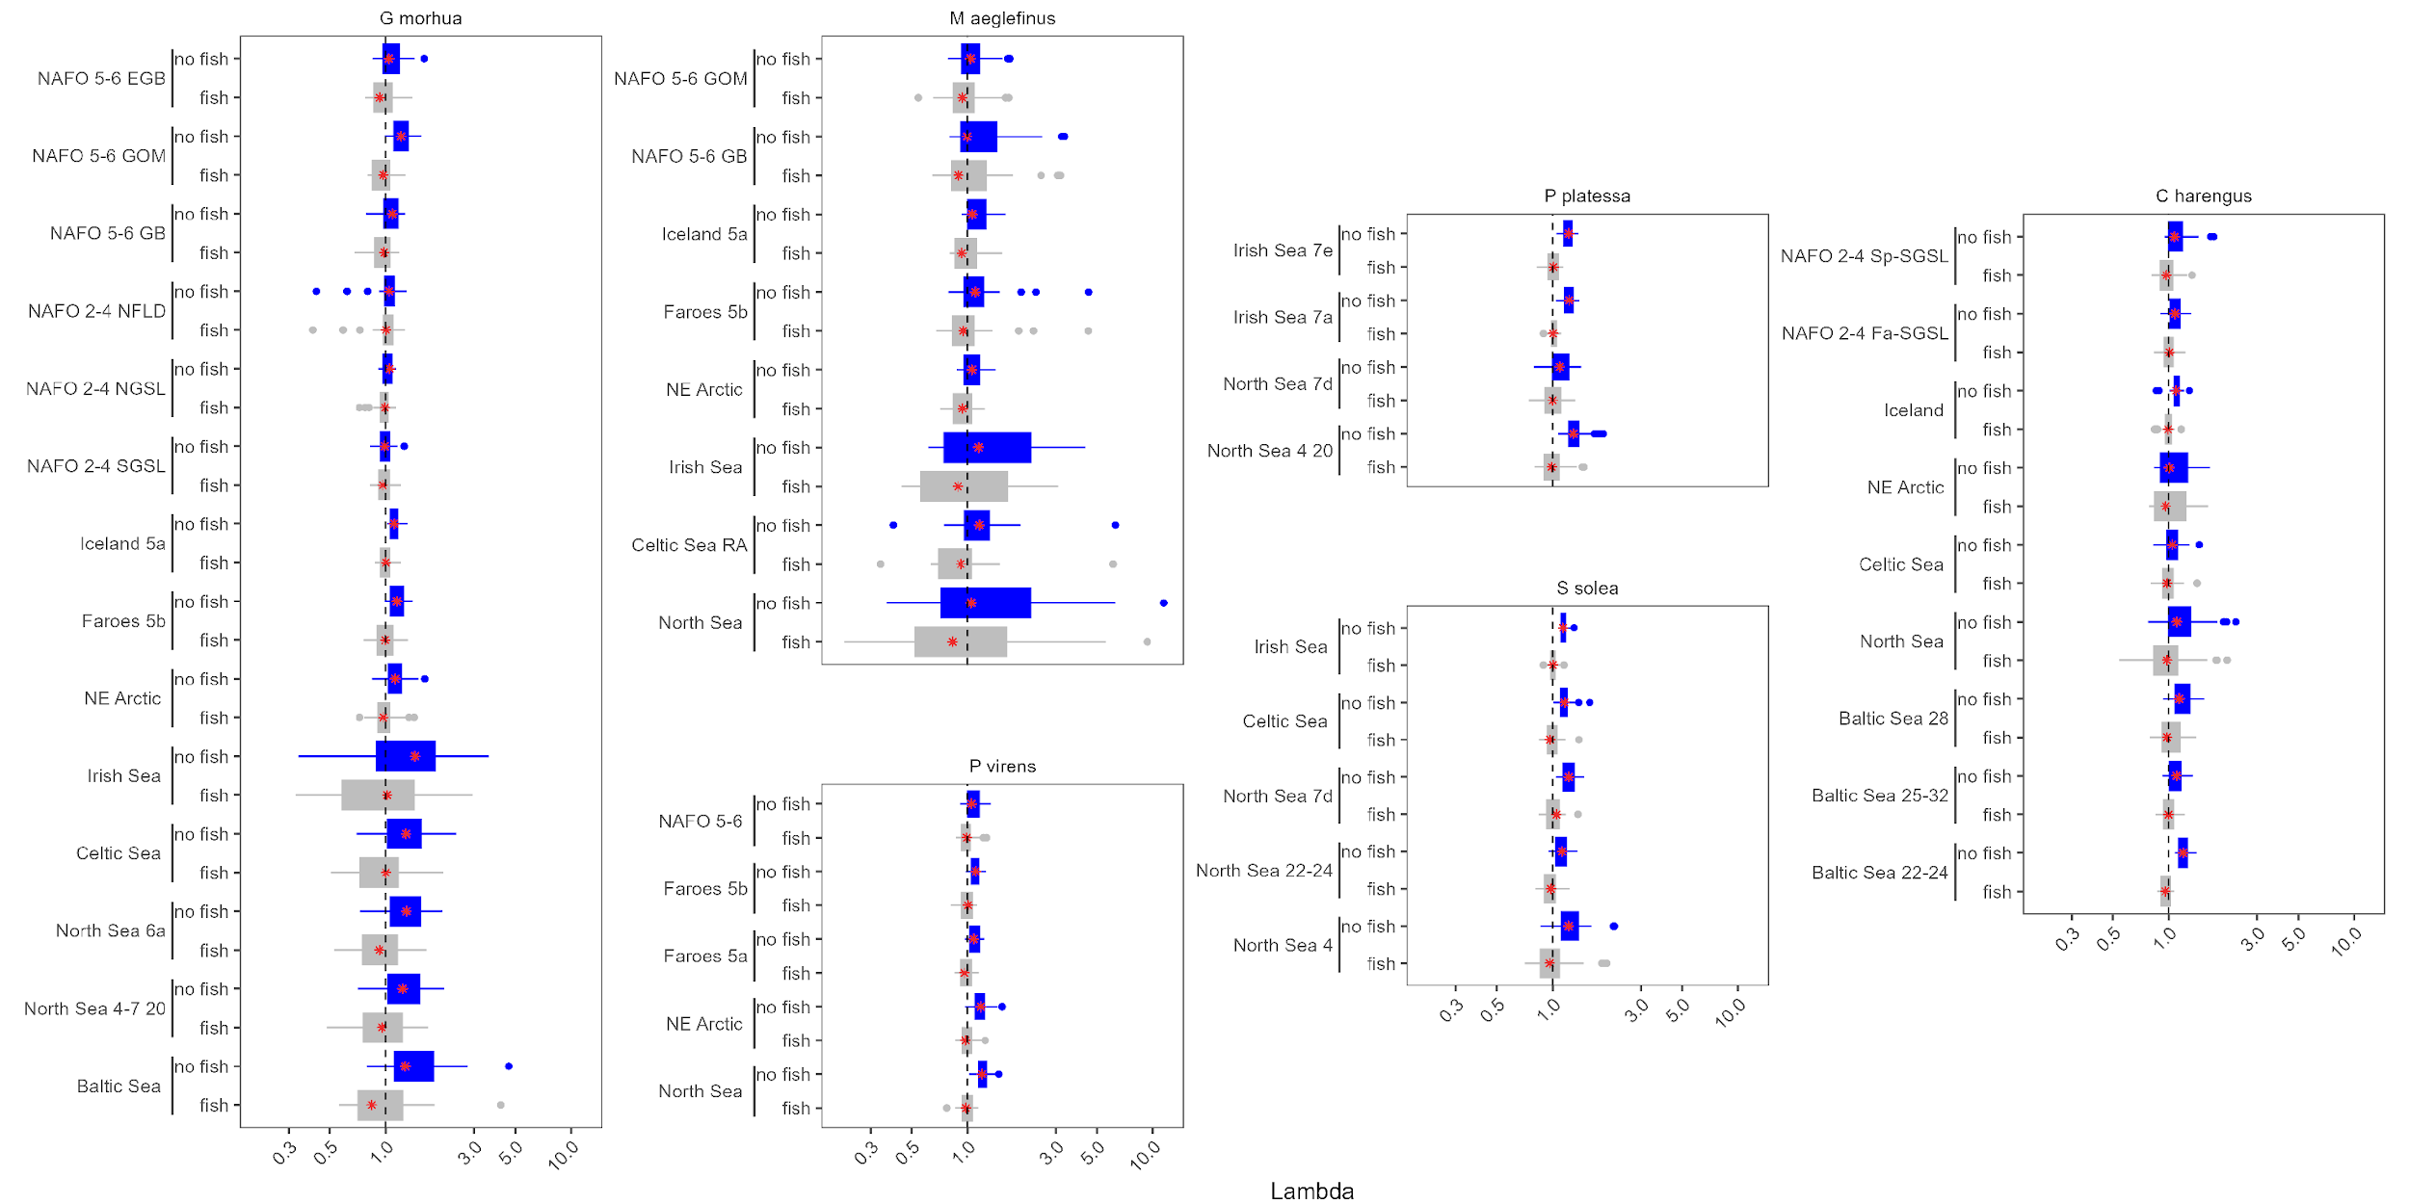
Figure 1: $λ$ estimates for each stock of G. morhua, M. aeglefinus, P. virens, C. harengus, P. platessa, and S. solea with (grey) and without (blue) fishing pressure. The red stars indicate the median values. The x-axis uses a log scale.

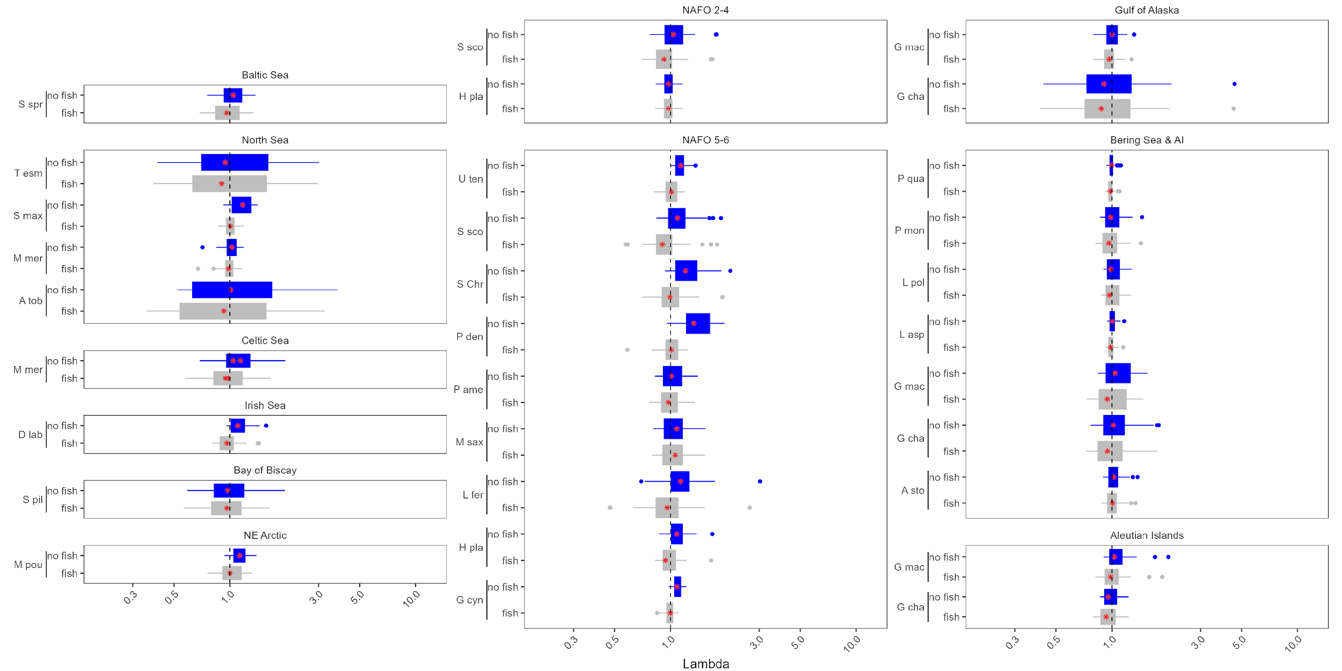
Figure 2: $λ$ estimates for the remainder of the stocks in this analysis, plotted with (grey) and without (blue) fishing pressure by the location of the stock. The abbreviated species name is provided on the y axis. The x axis is on a log scale. Refer to Supplementary Table X for full species names.

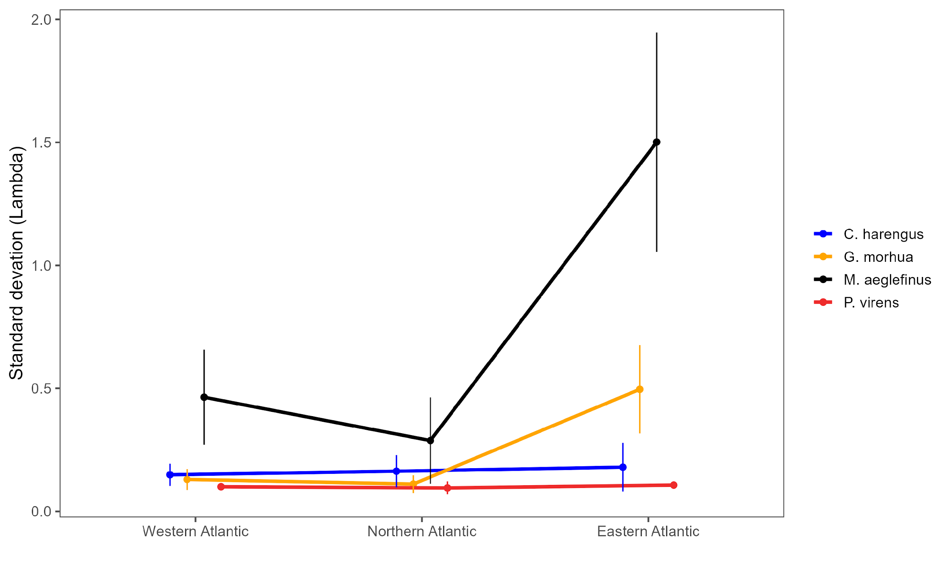
Figure 3: The average standard deviation of $λ_{F=0}$ for Atlantic herring (C. harengus), Atlantic cod (G. morhua), haddock (M. aeglefinus), and pollock (P. virens) stocks in the western Atlantic (NAFO regions 2-5), northern Atlantic (Iceland, Faroe Islands, and the northeast Arctic), and eastern Atlantic (Irish, Celtic, North, and Baltic Seas). The error bars represent one standard deviation.

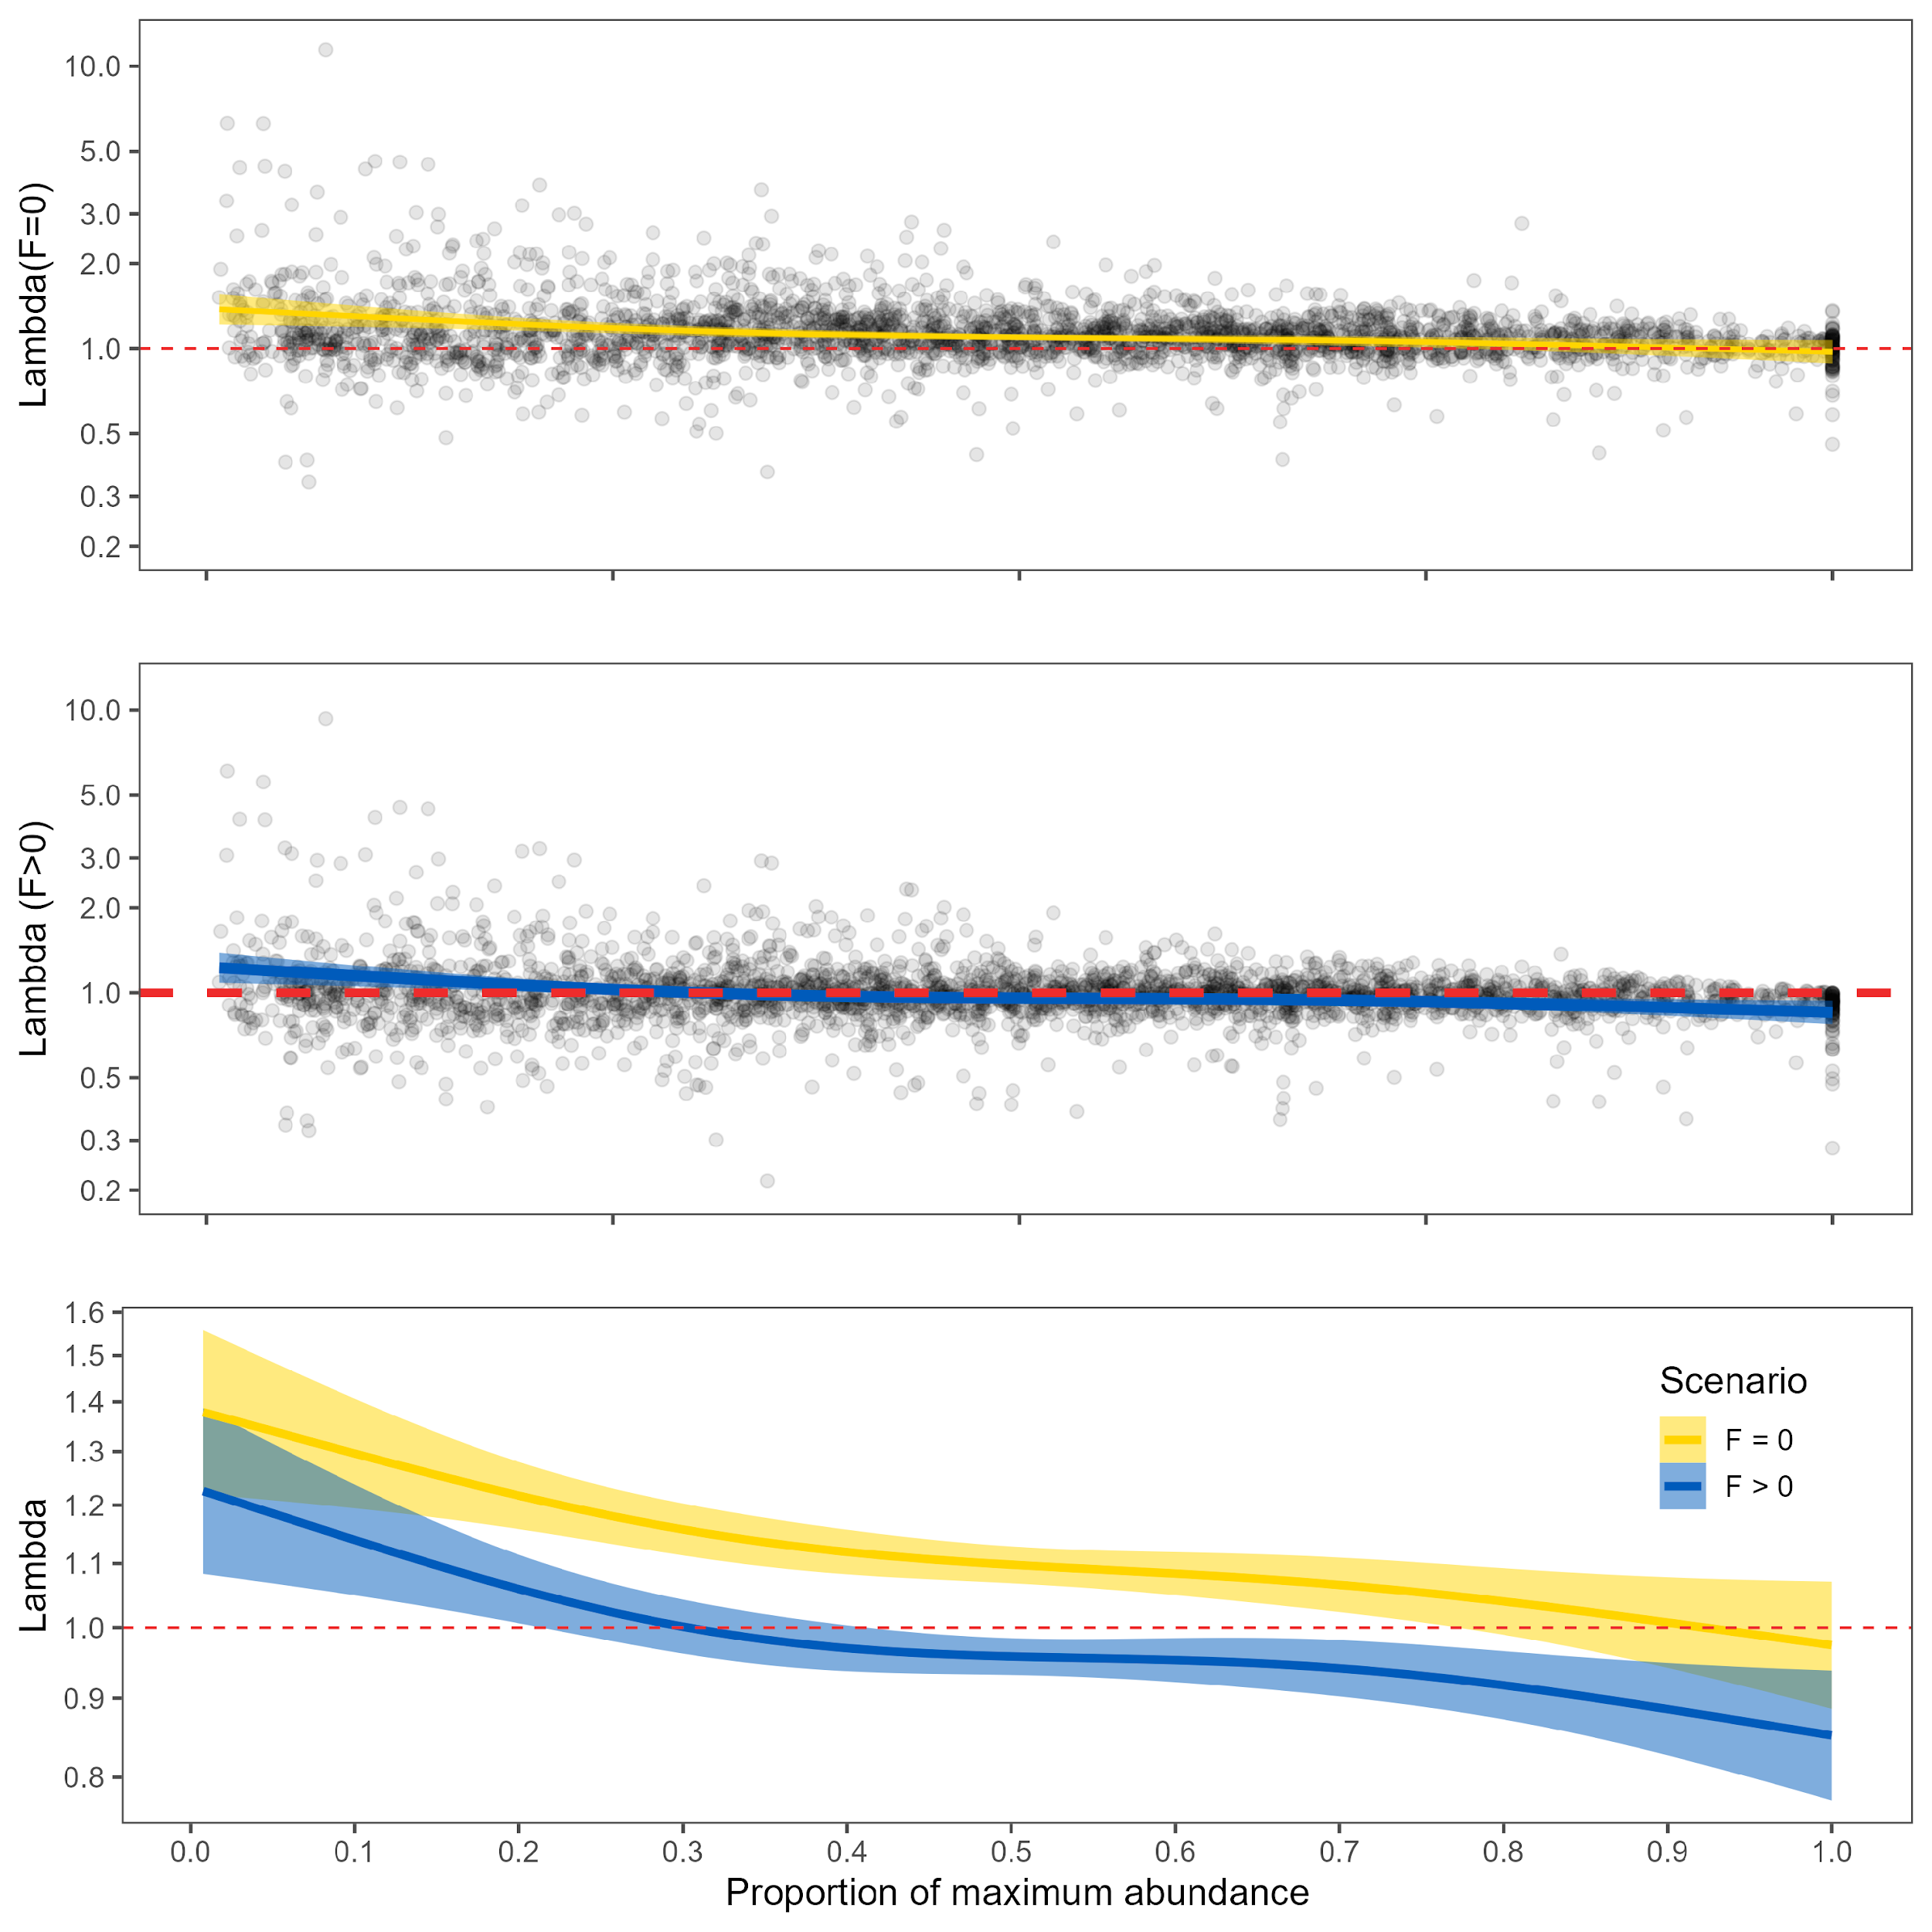
Figure 4: Density dependence of $λ$. The top panel shows $λ_{F=0}$ against the proportion of maximum abundance, with a GAM smooth and the GAM estimated 95% confidence interval. The middle panel shows $λ_{F>0}$ against the proportion of maximum abundance, with a GAM smooth and its estimated 95% confidence interval. The bottom panel compares the GAM smooths for $λ_{F=0}$ and $λ_{F>0}$.

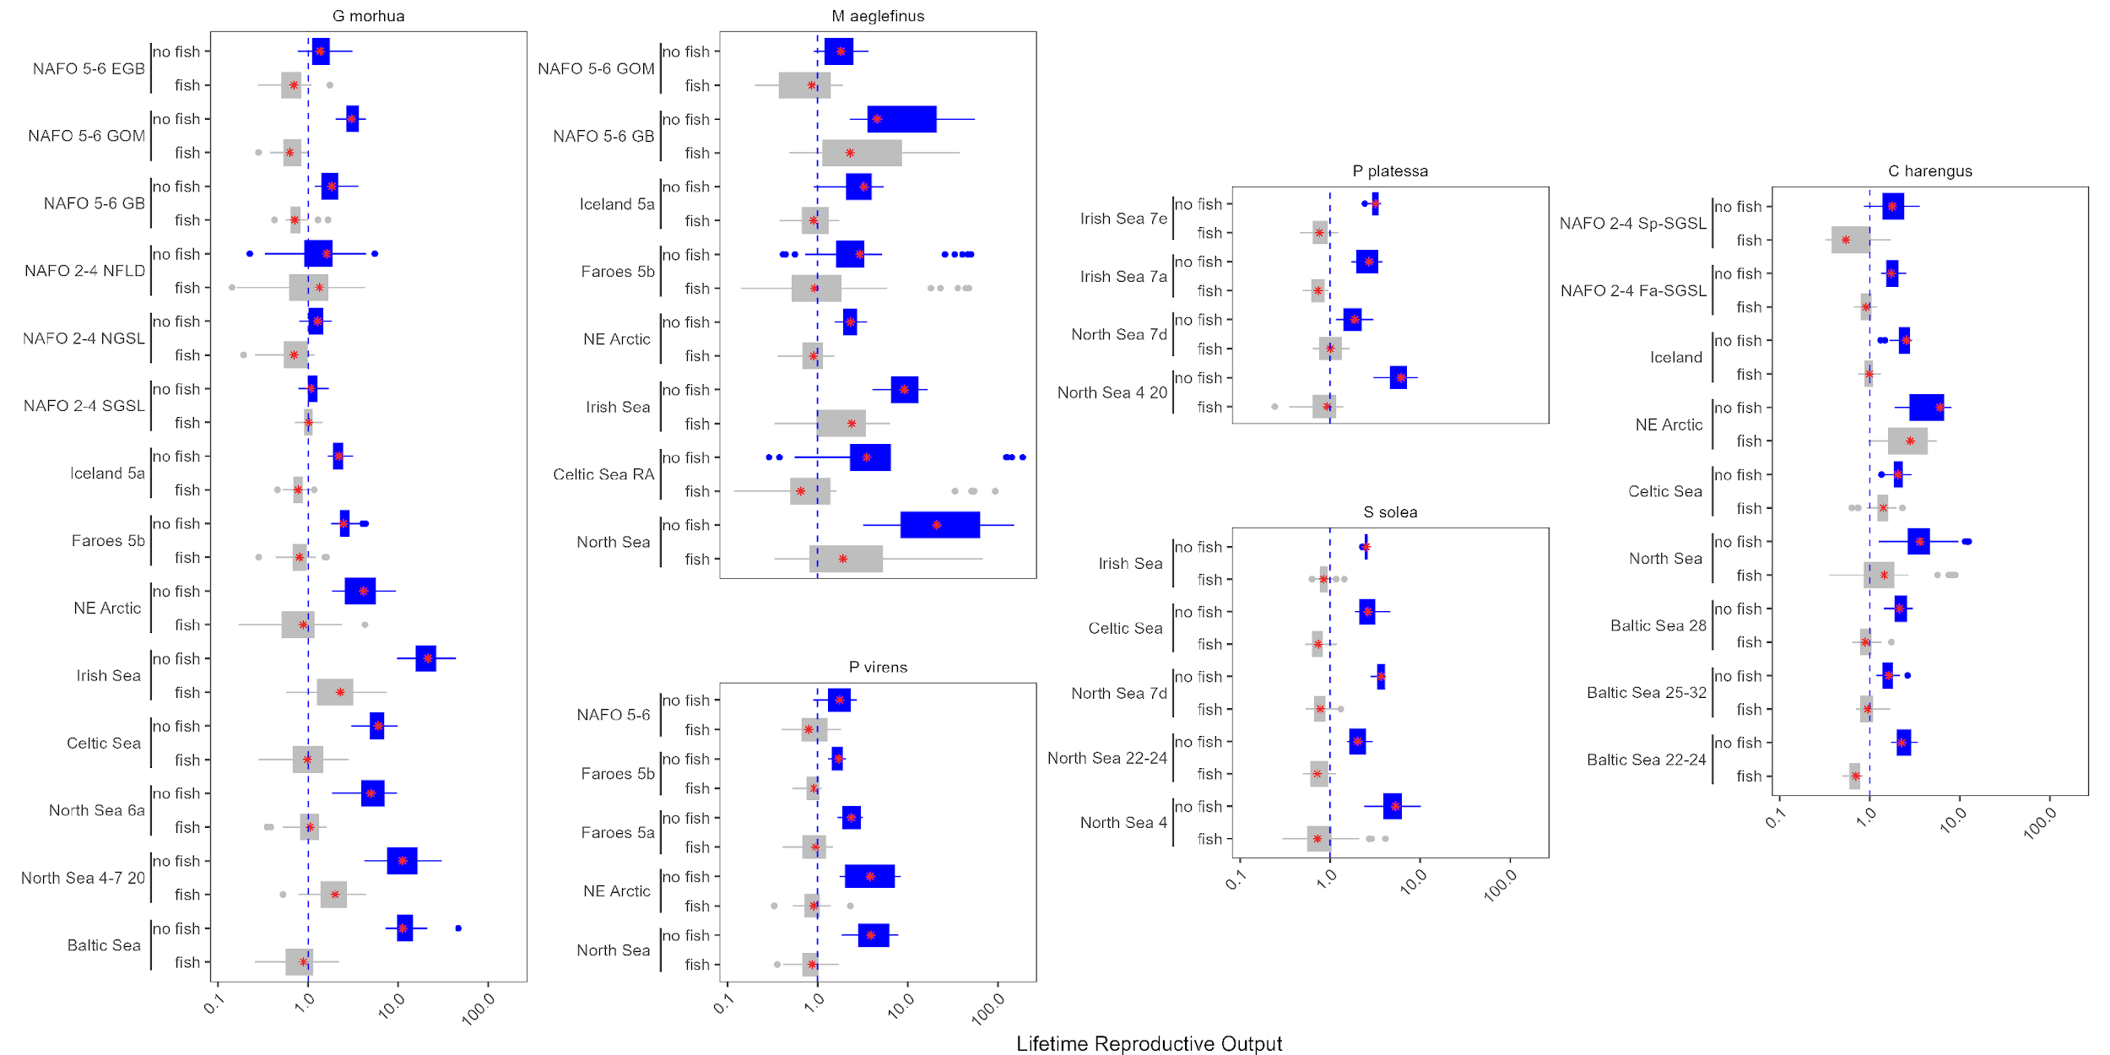
Figure 5: Lifetime reproductive success (R0)R0 estimates for each stock of G. morhua, M. aeglefinus, P. virens, C. harengus, P. platessa, and S. solea with (grey) and without (blue) fishing pressure.

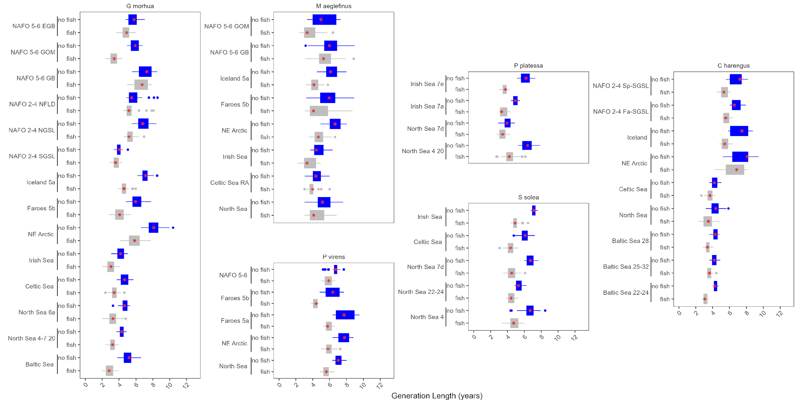
Figure 6: Generation timeestimates for each stock of G. morhua, M. aeglefinus, P. virens, C. harengus, P. platessa, and S. solea with (grey) and without (blue) fishing pressure.

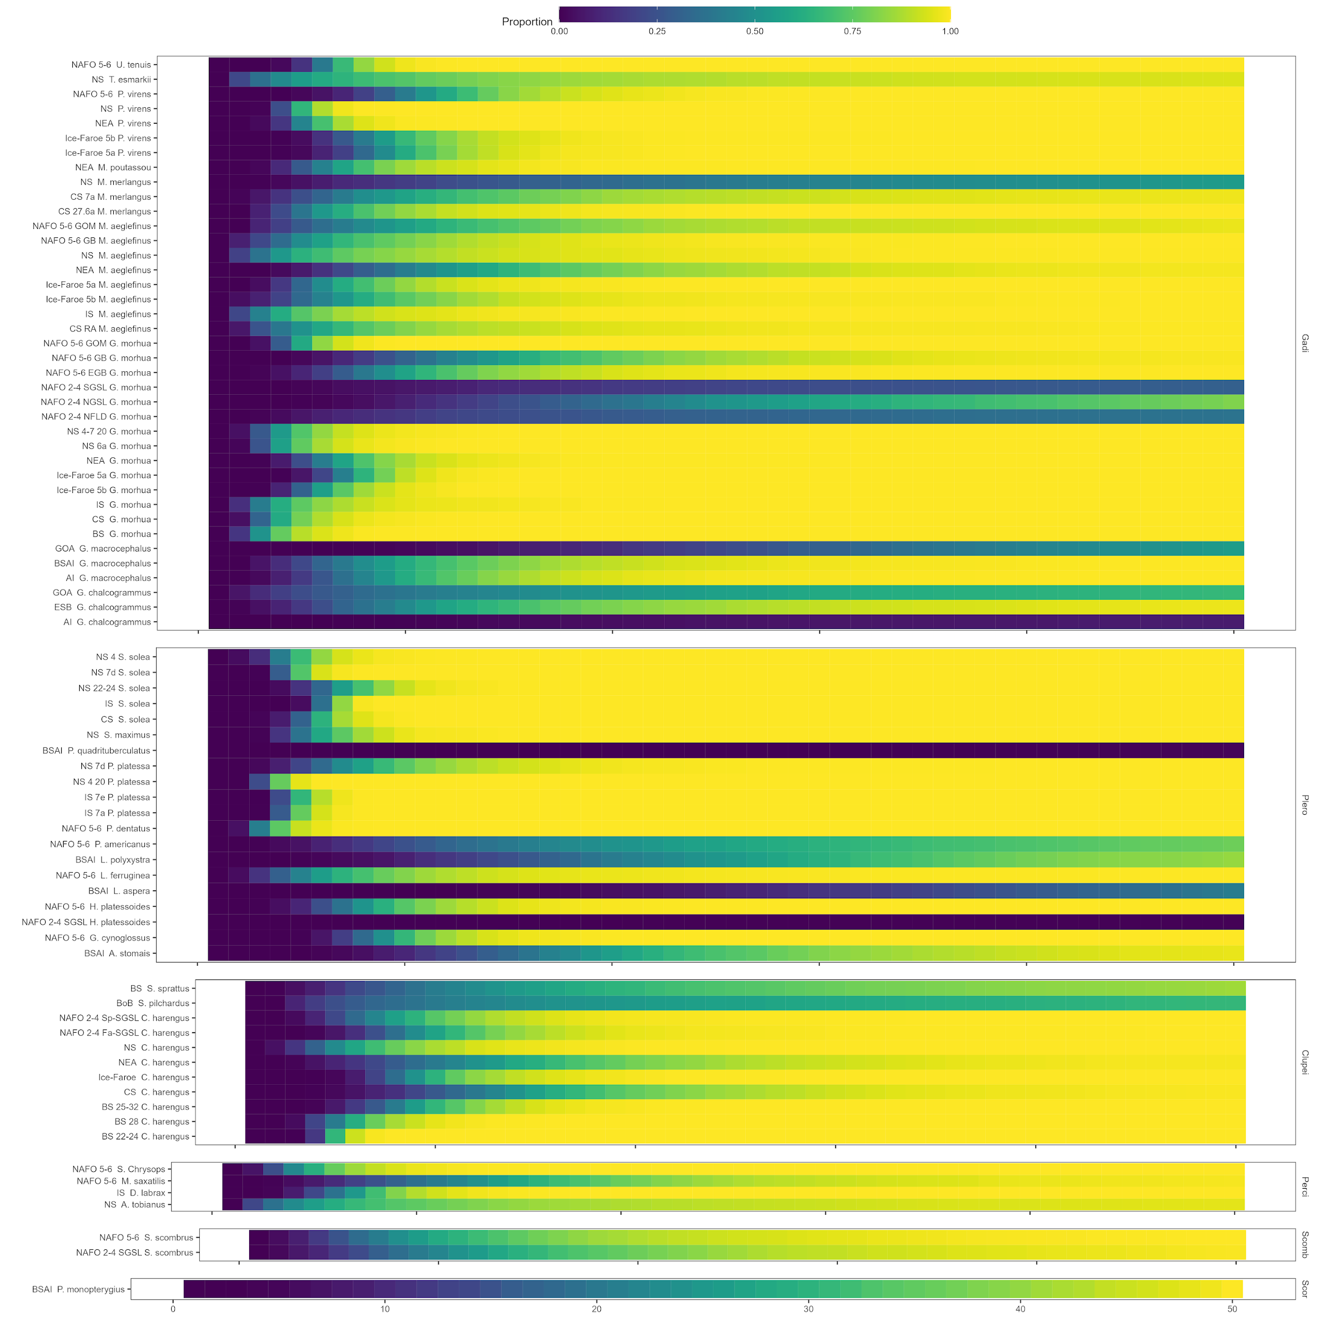
Figure 7: Proportion of doubling time estimates for simulated trajectories of each stock with no fishing mortality.
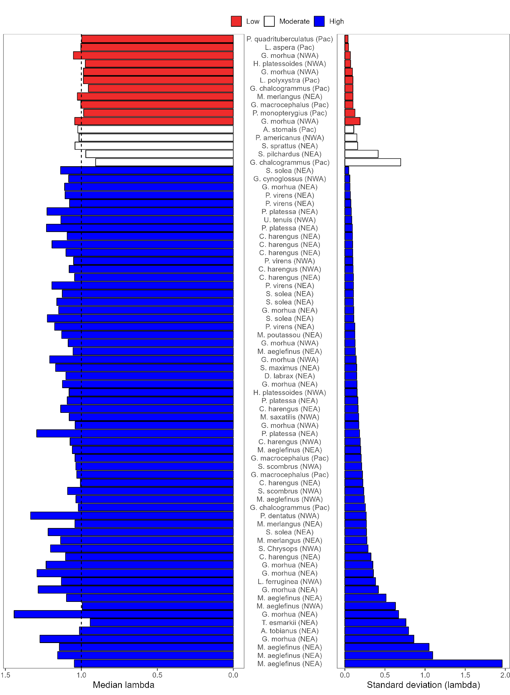
Figure 8: The recovery potential (low, moderate, or high) of each stock after 20 years compared to the median $λ_{F=0}$ and the standard deviation of $λ_{F=0}$.

APPENDIX A

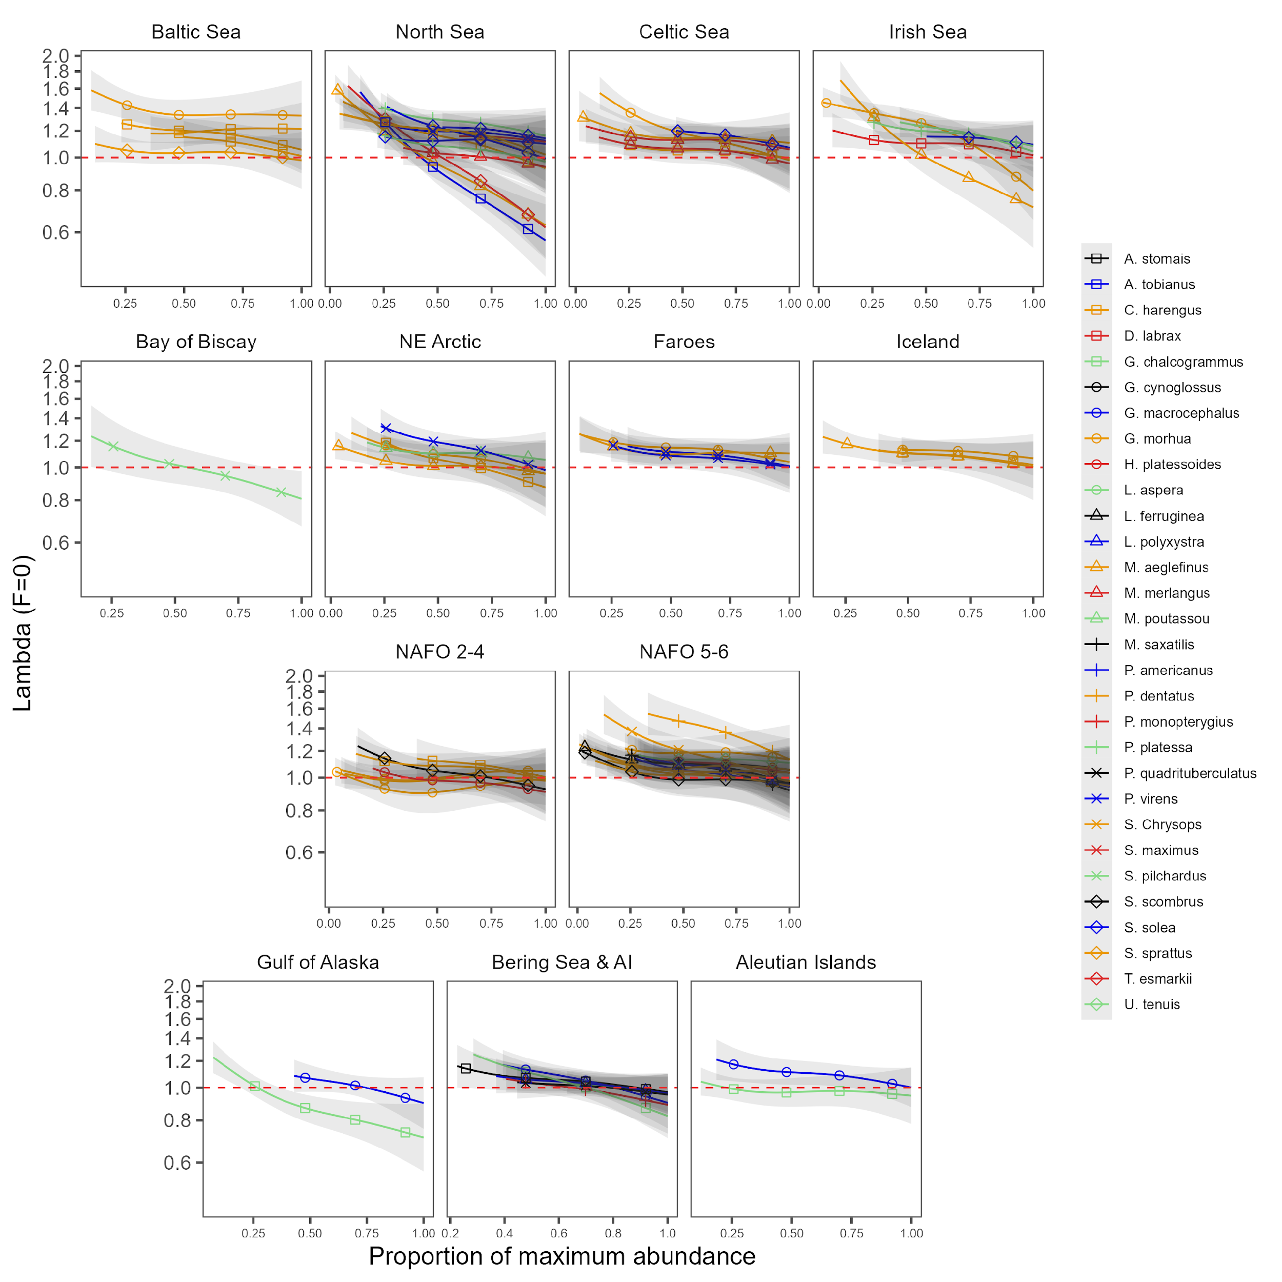
Figure 9: Density dependence of $λ_{F=0}$ for each stock in the analysis plotted regionally.

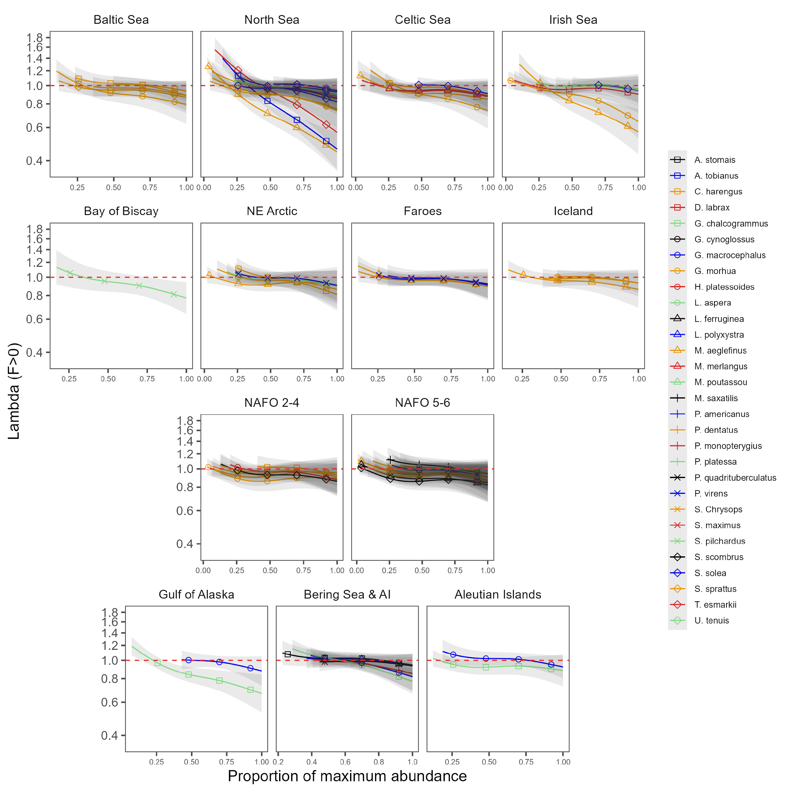
Figure 10: Density dependence of $λ_{F>0}$ for each stock in the analysis plotted regionally.

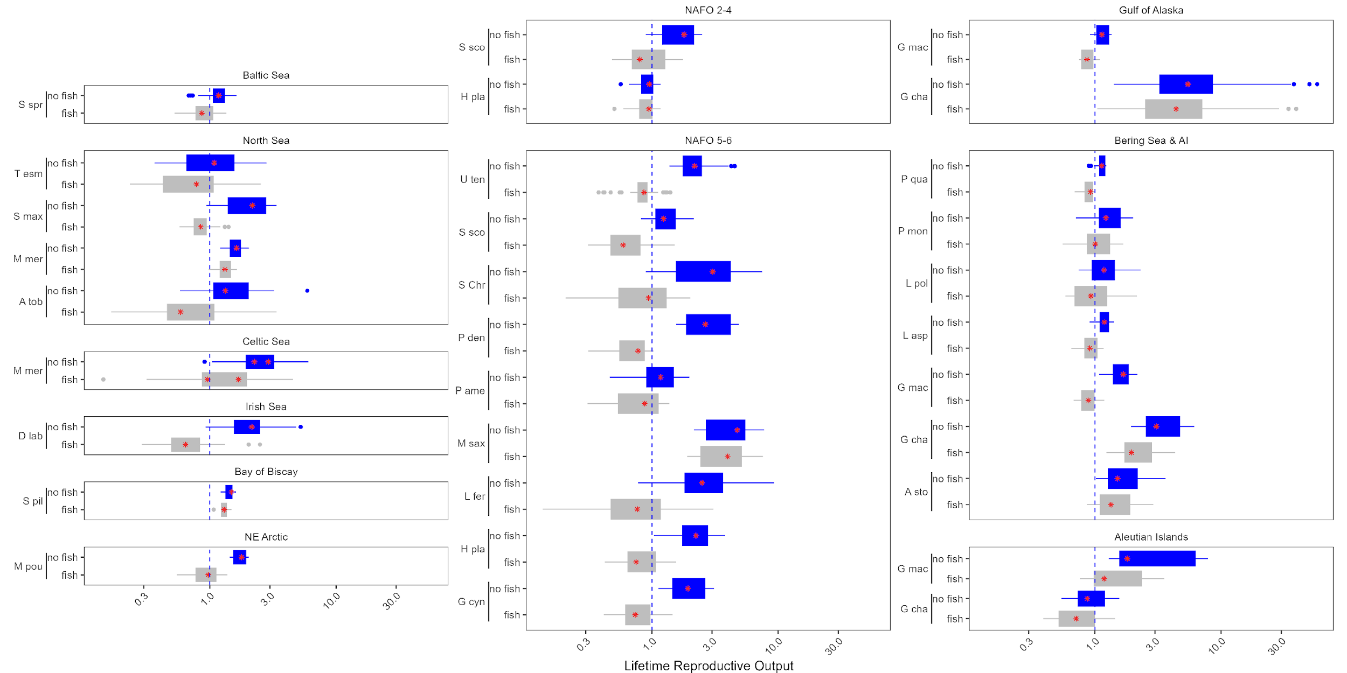
Figure 11: Lifetime reproductive success (R0)R0 estimates for the remainder of the stocks in this analysis with (grey) and without (blue) fishing pressure, plotted by the location of the stock. The abbreviated species name is provided on the x axis.

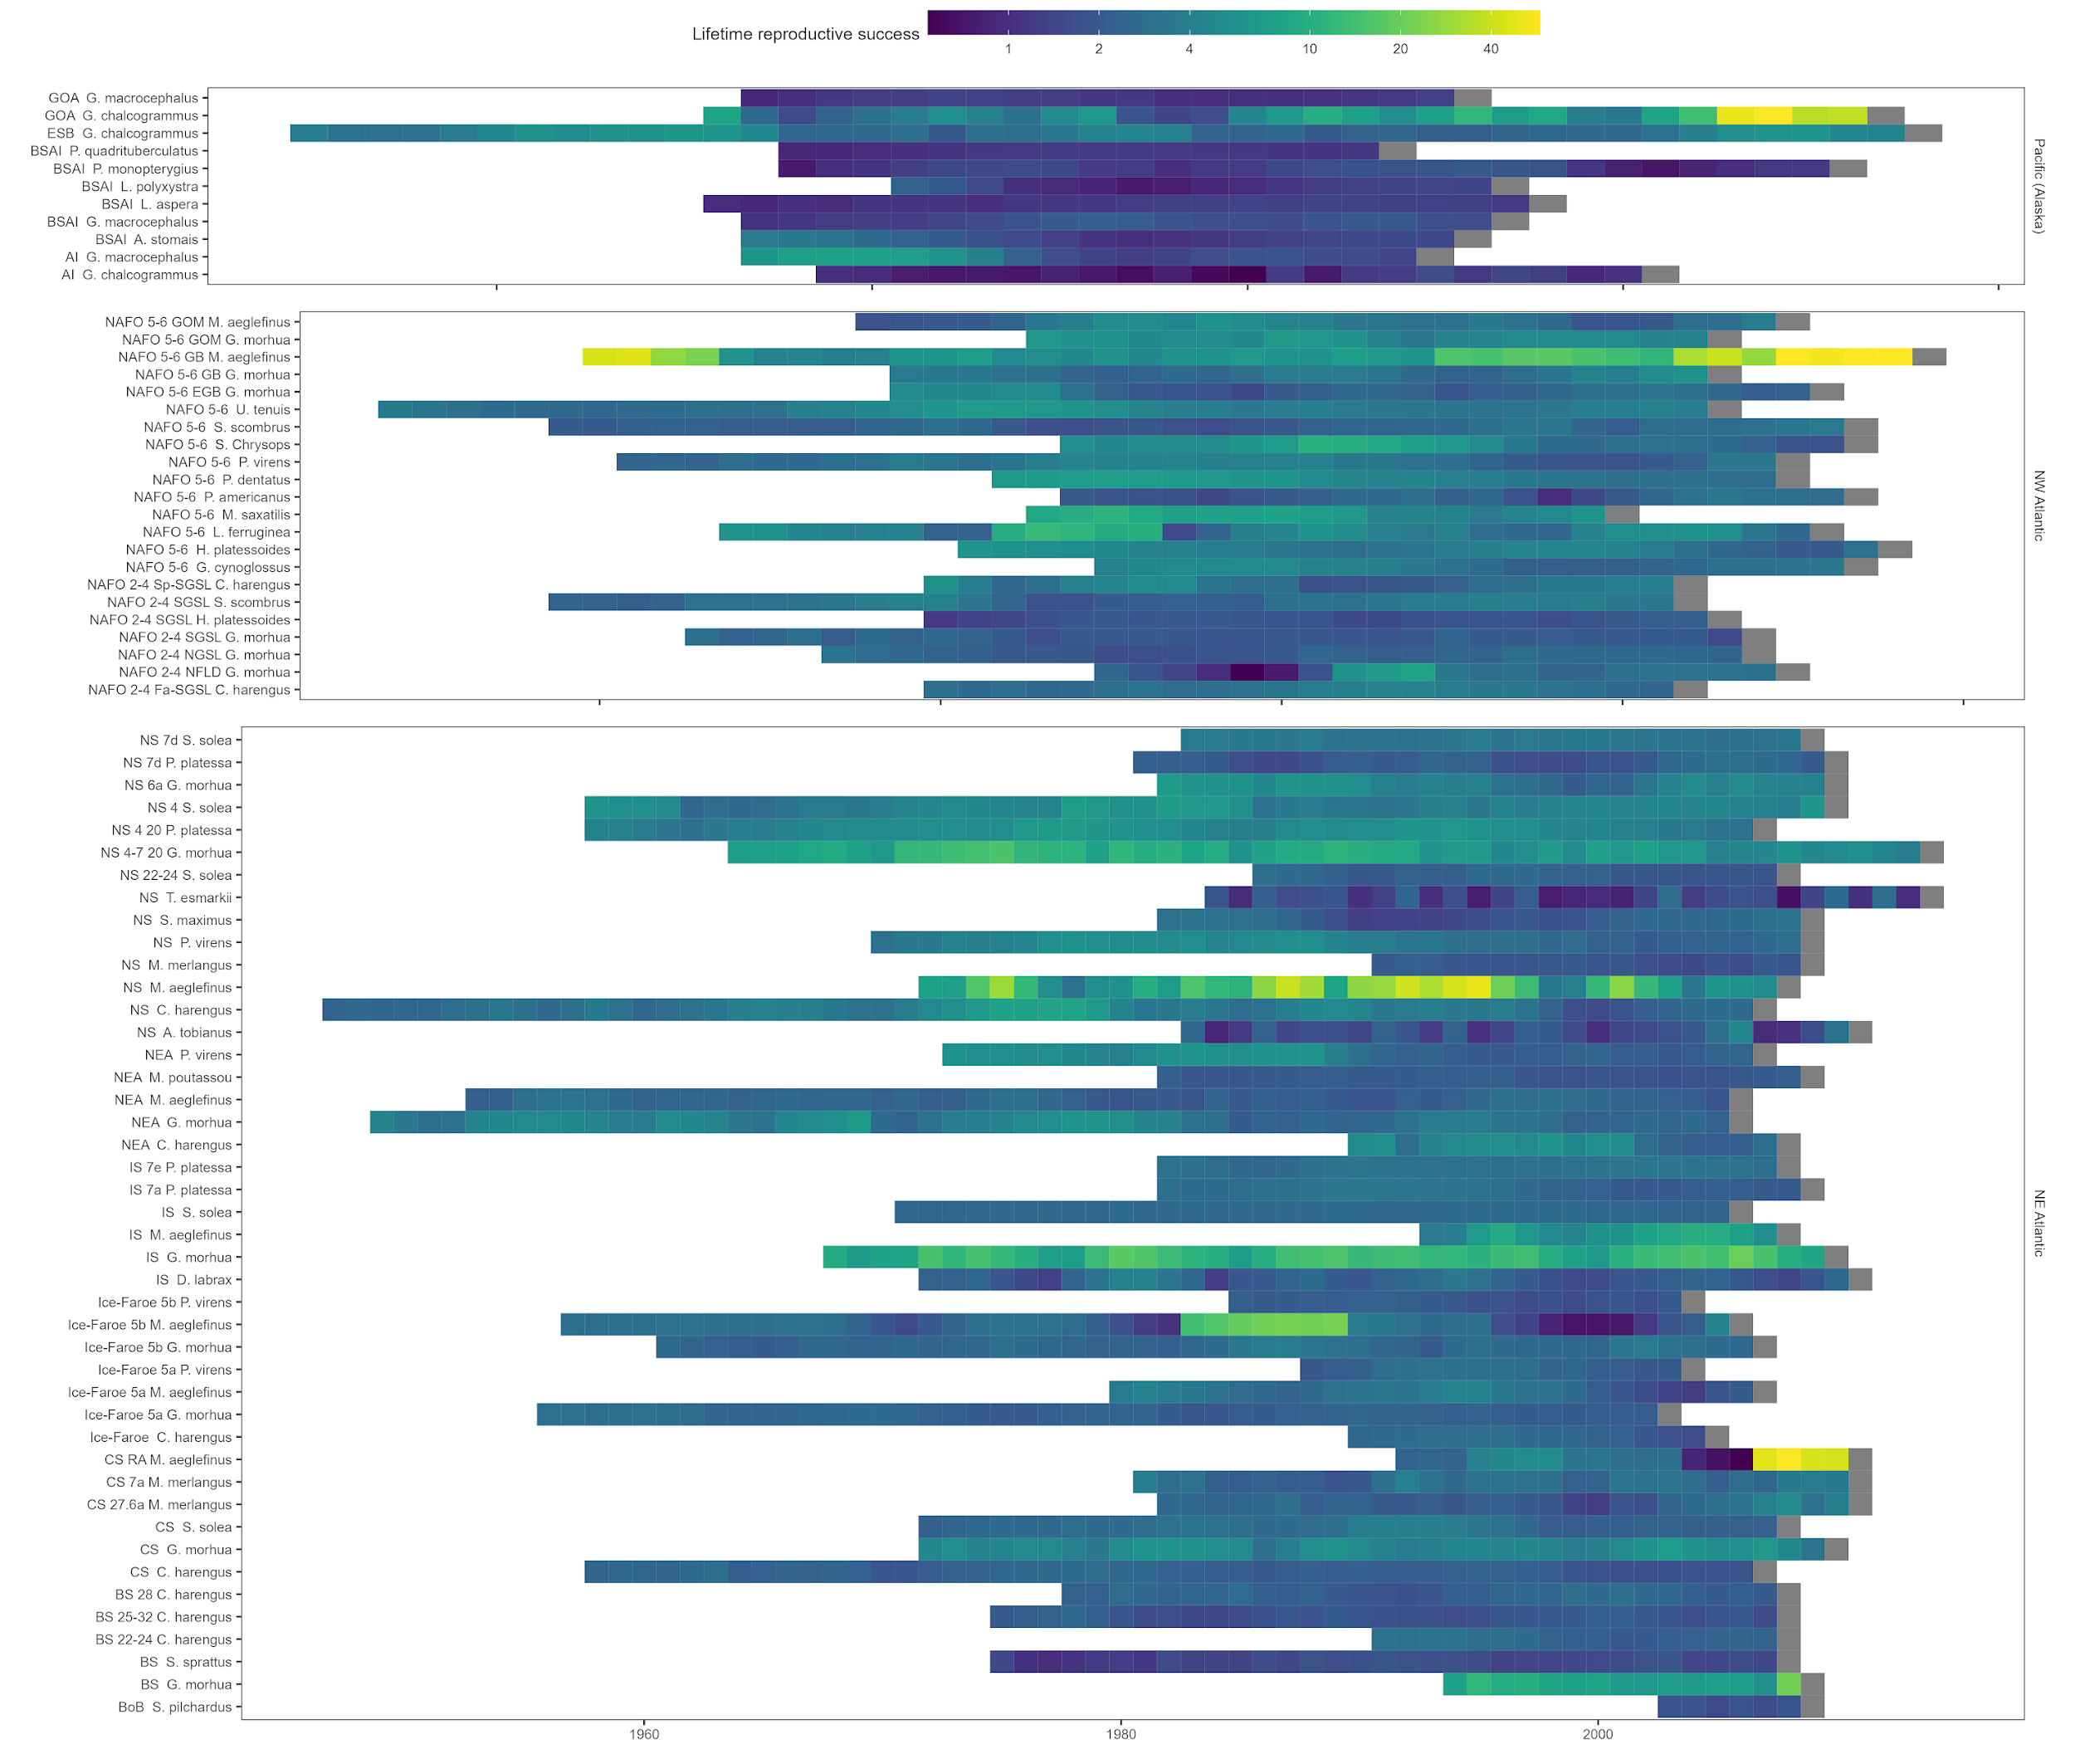
Figure 12: Lifetime reproductive success (R0)R0 estimates for every cohort for each species excluding the effects of fishing.
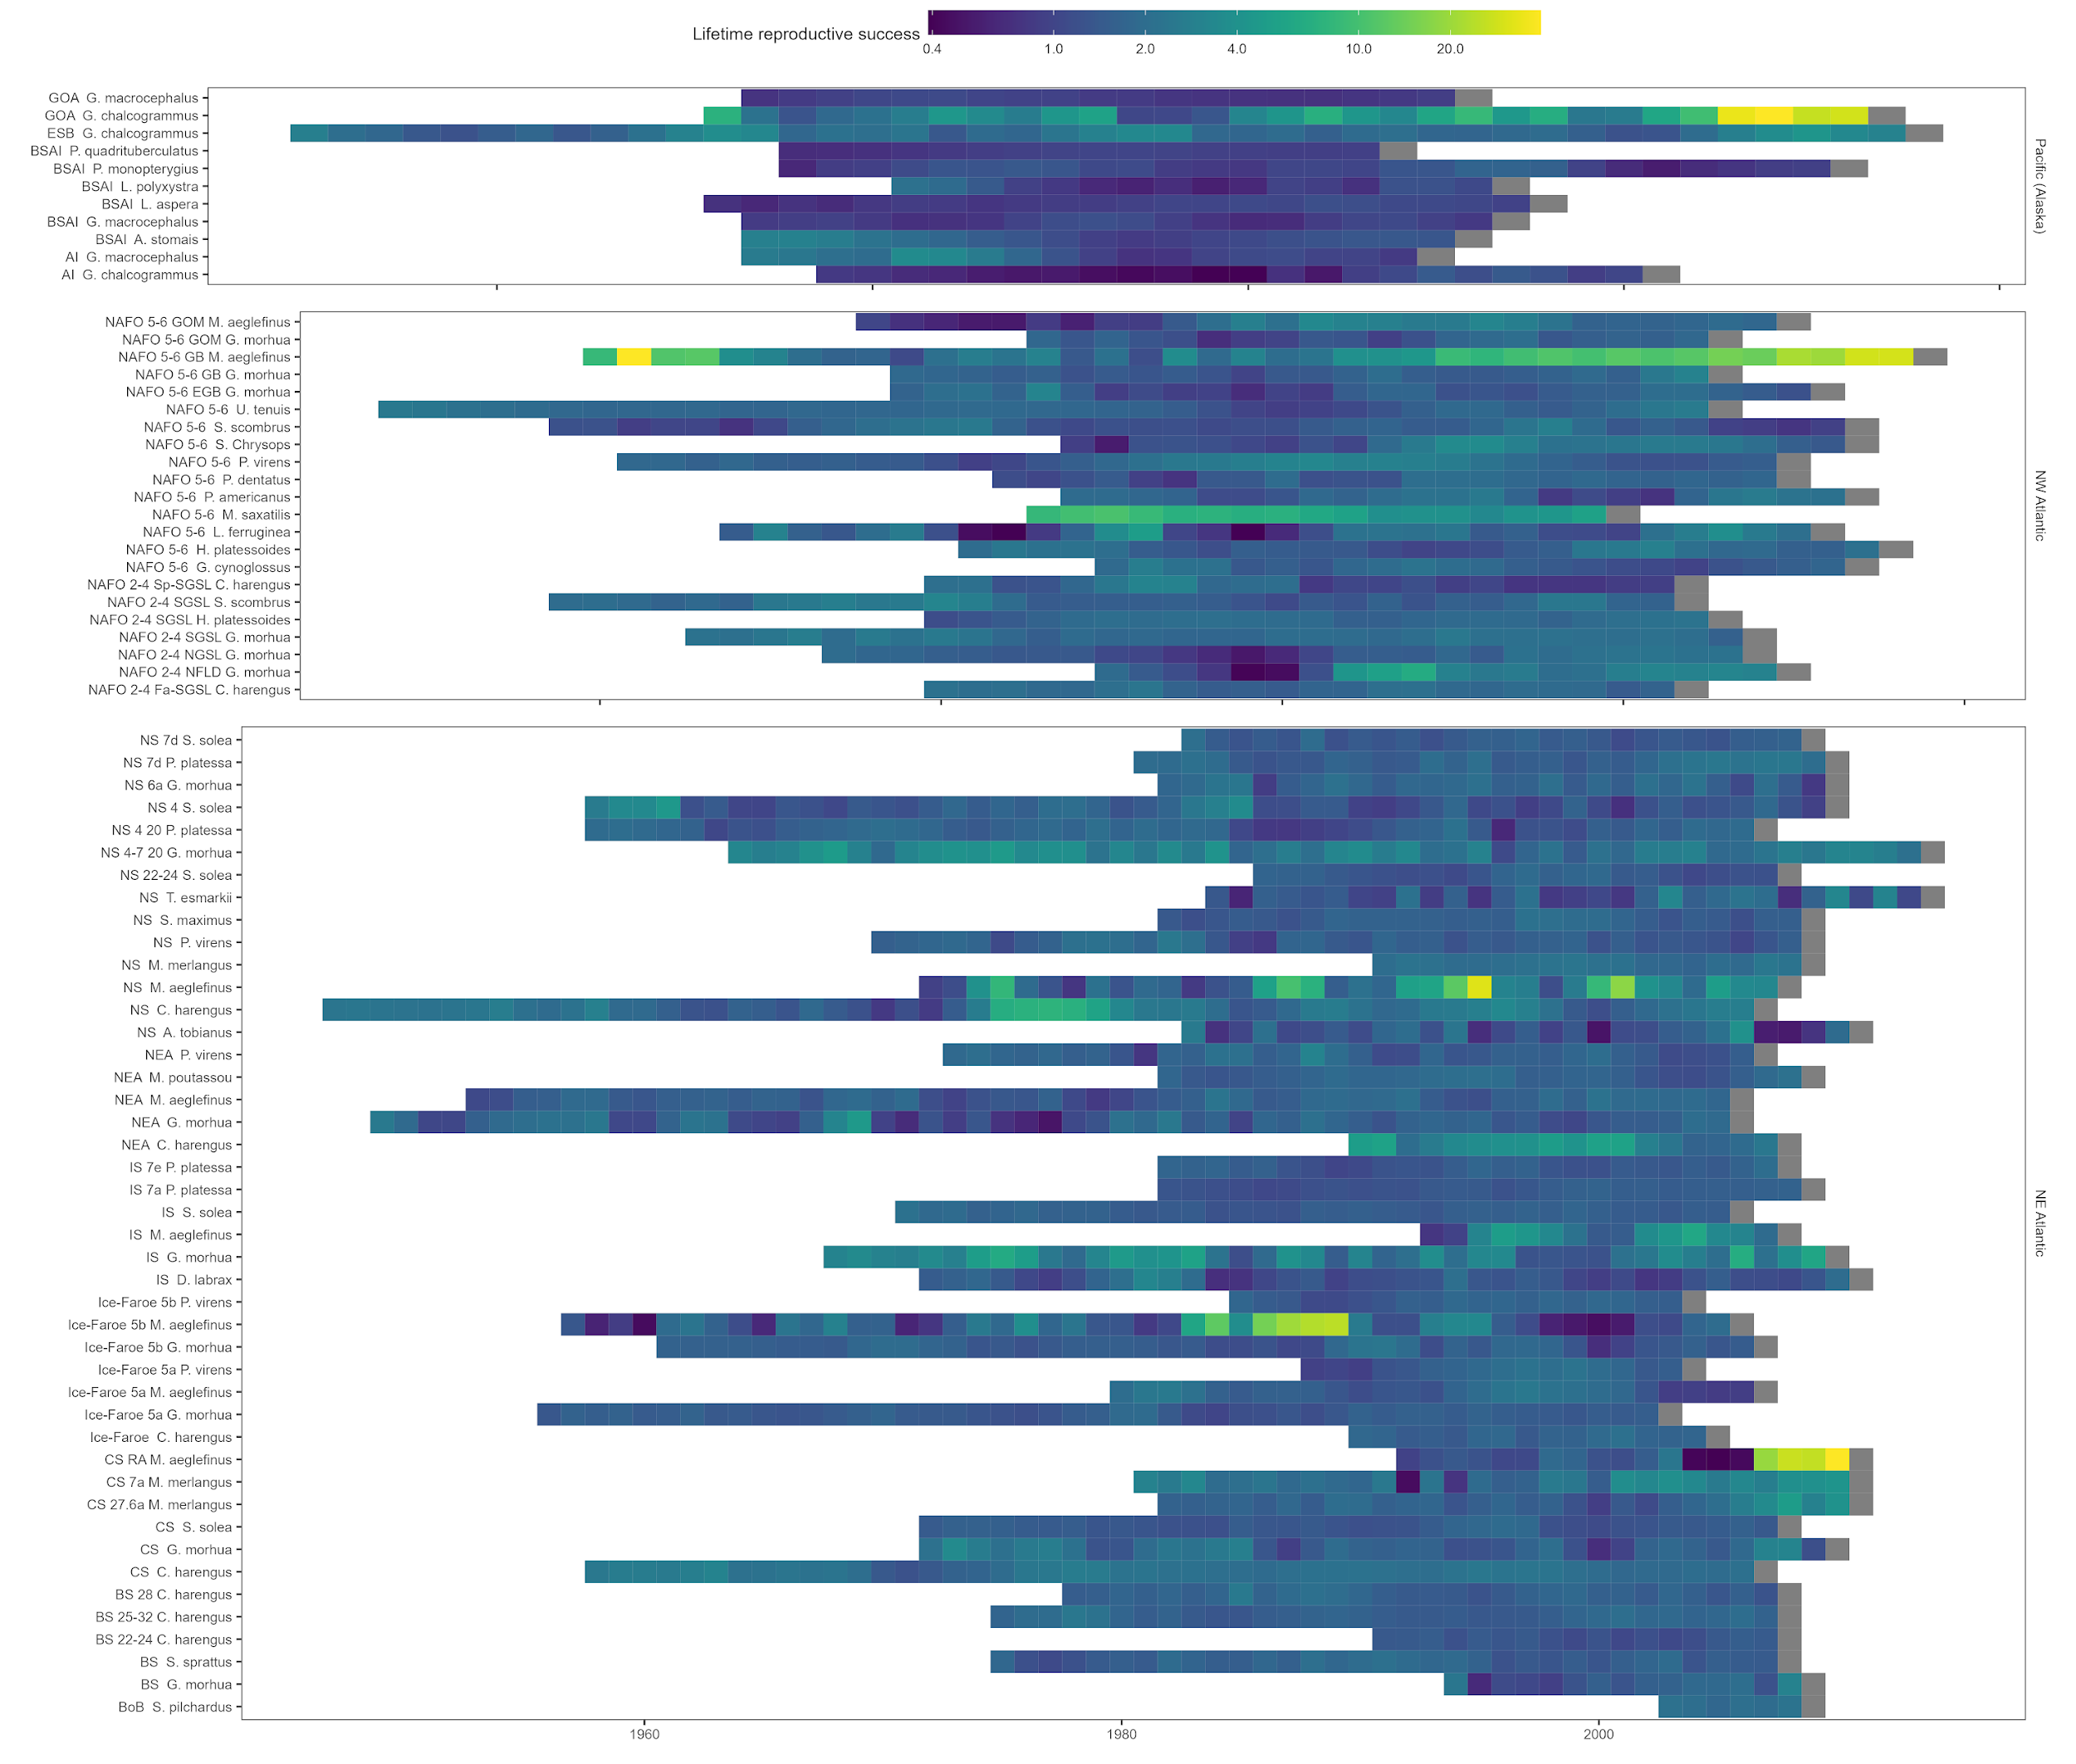
Figure 13: Lifetime reproductive success (R0)R0 estimates for every cohort for each species including the effects of fishing.

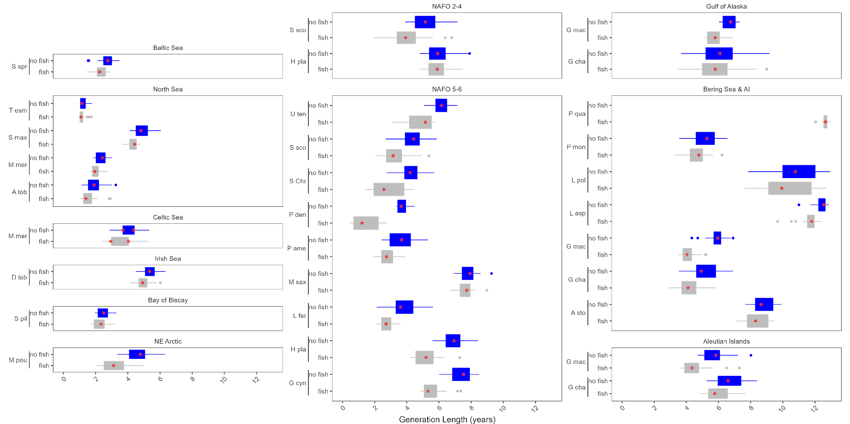
Figure 14: Generation time estimates for the remainder of the stocks in this analysis with (grey) and without (blue) fishing pressure, plotted by the location of the stock. The abbreviated species name is provided on the x axis.

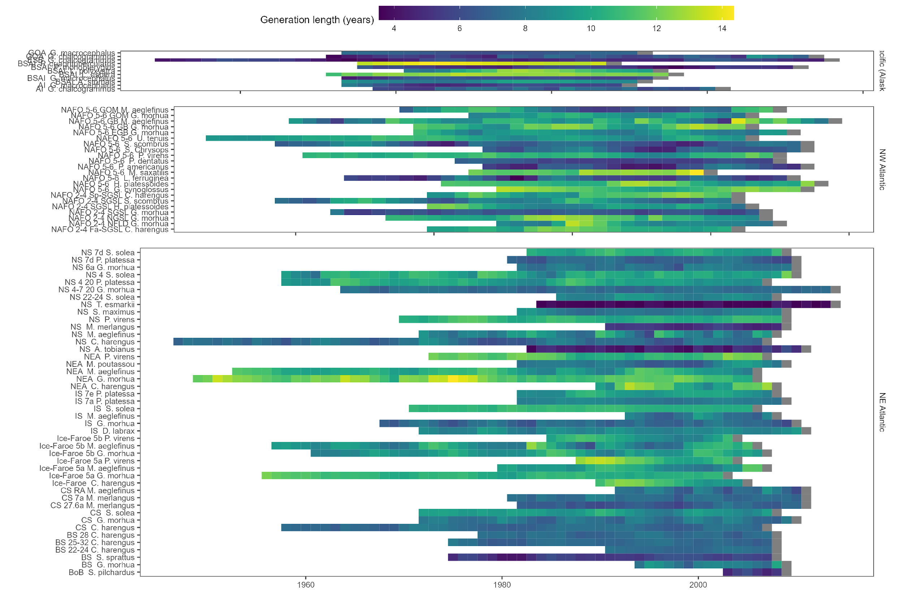
Figure 15: Generation time estimates for every cohort for each species excluding the effects of fishing.

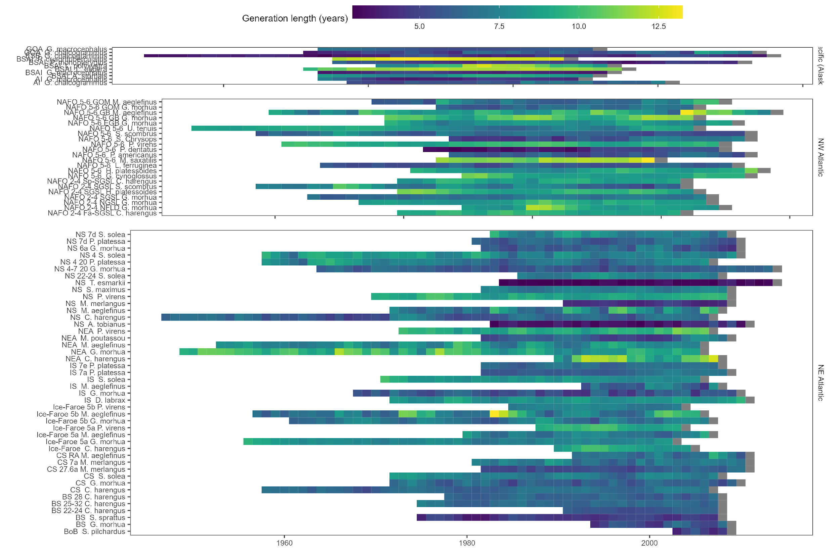
Figure 16: Generation time estimates for every cohort for each species including the effects of fishing.

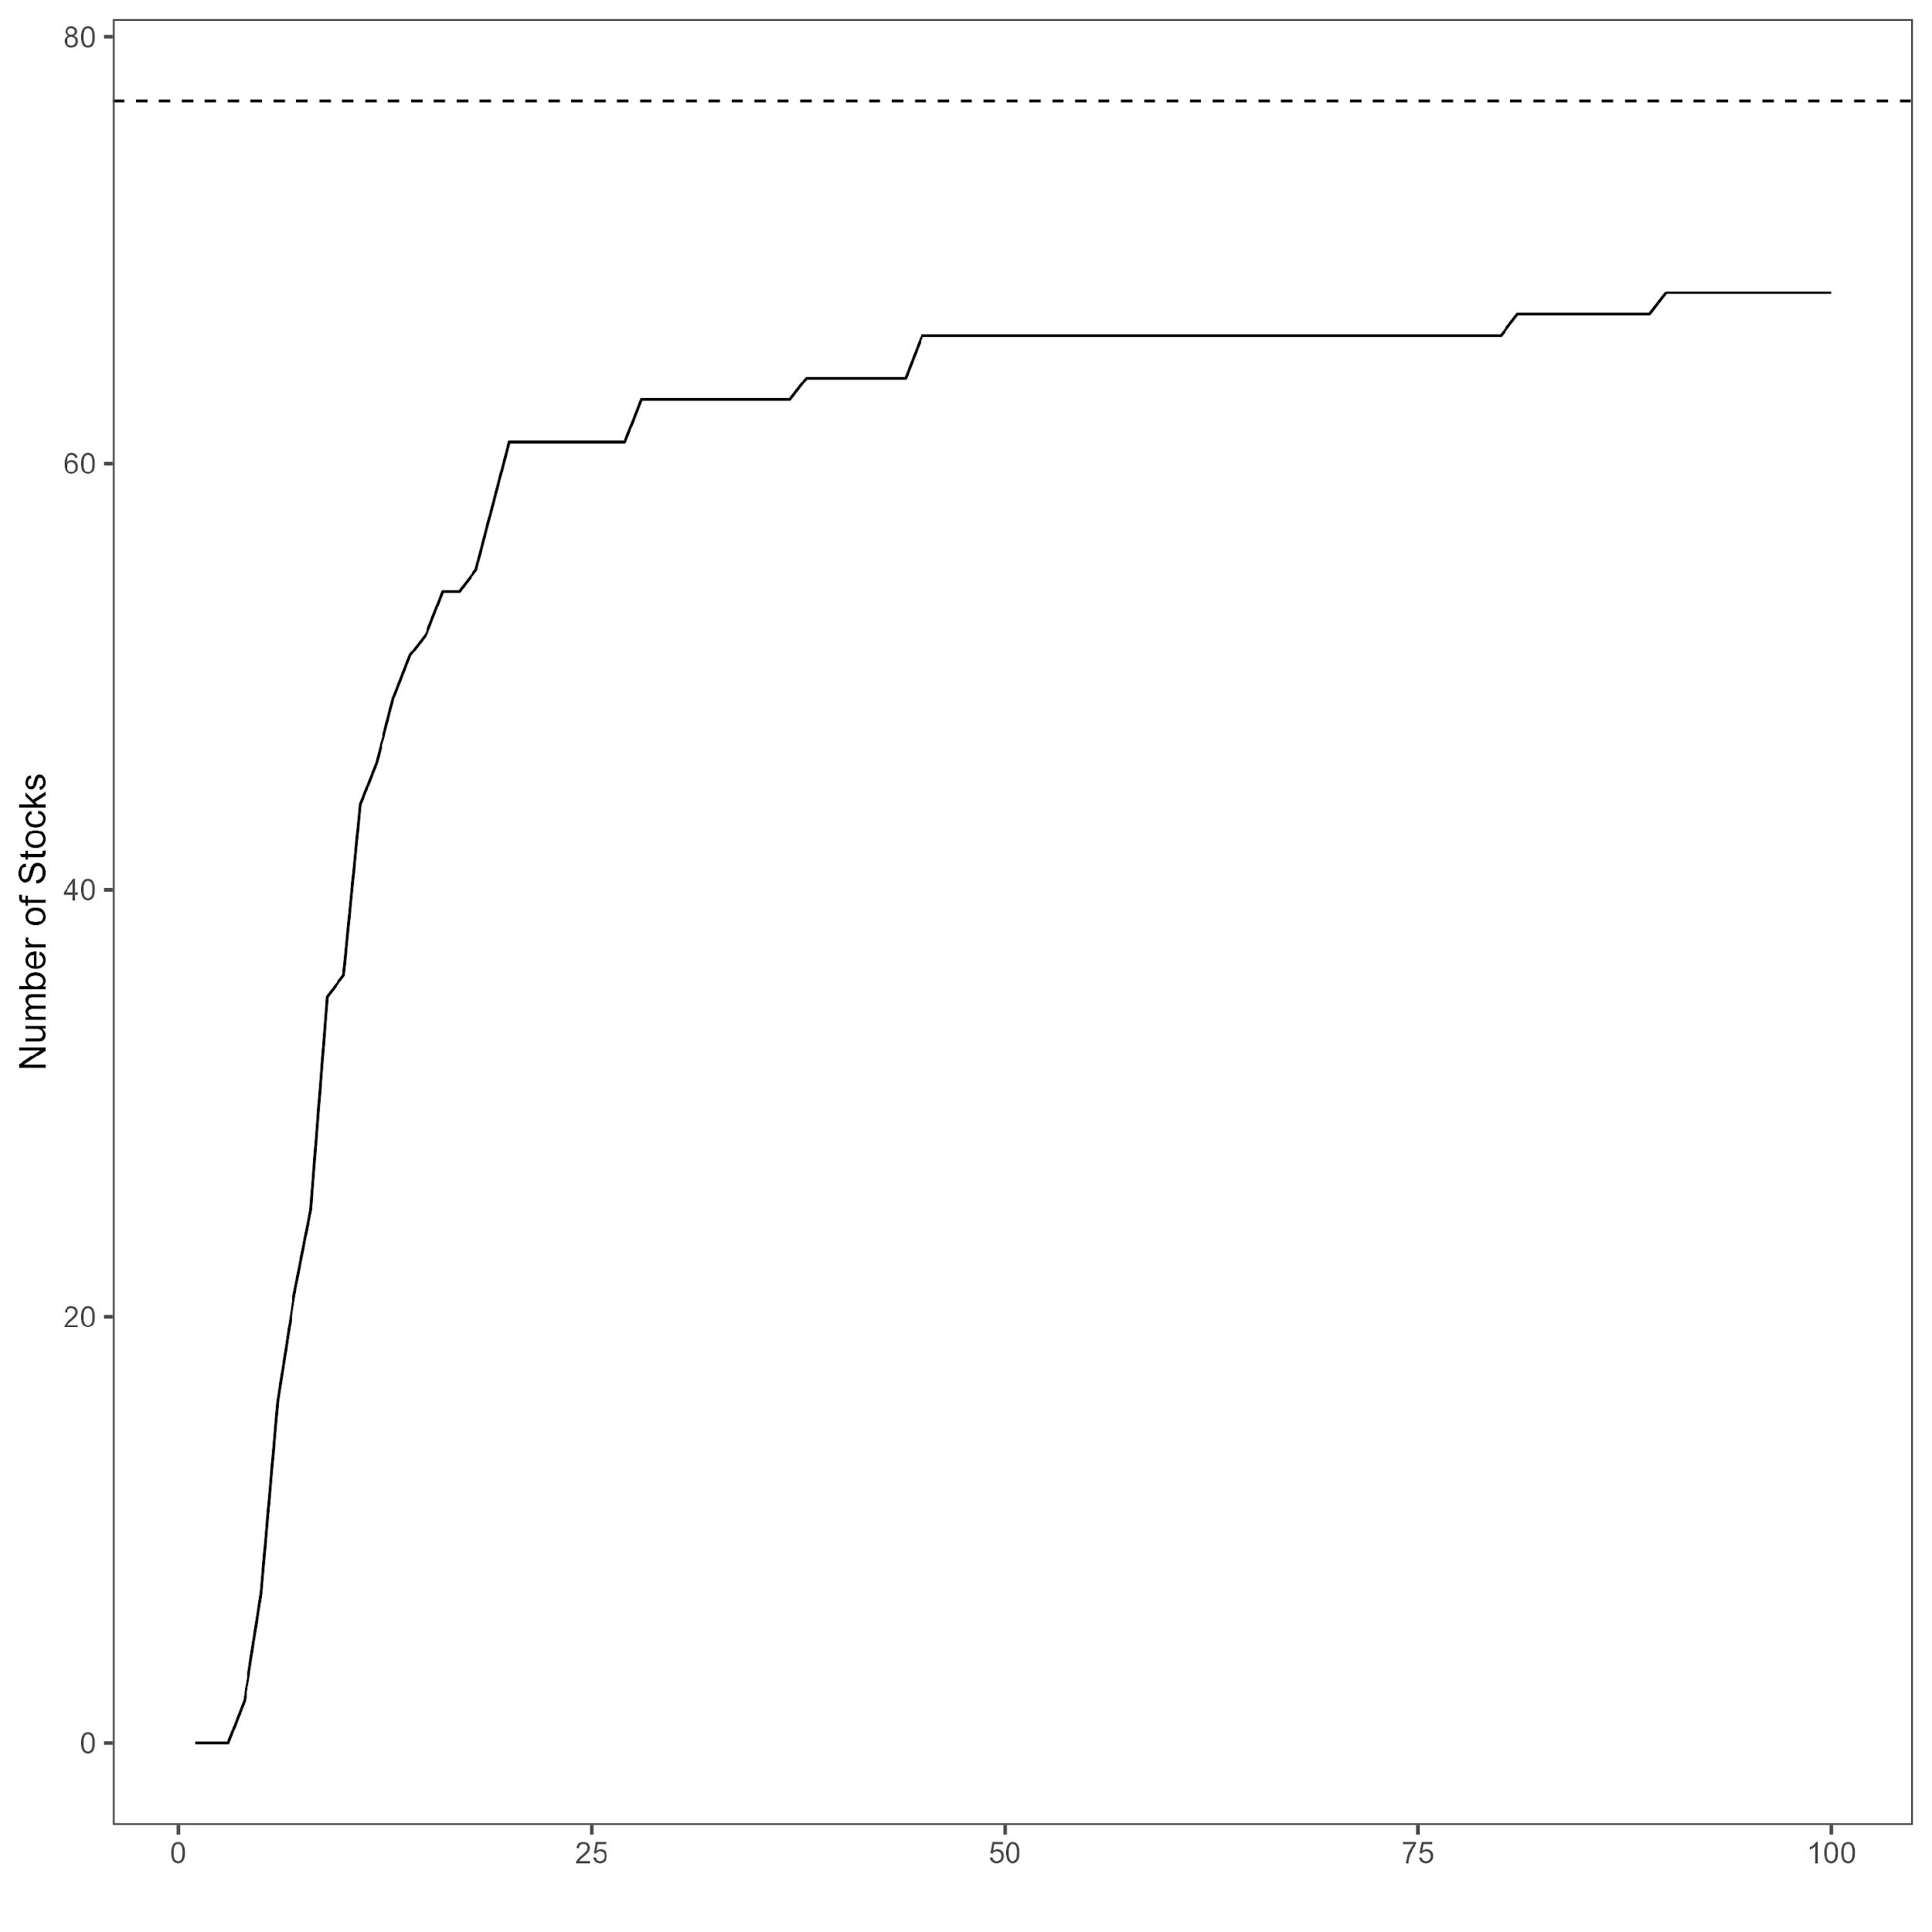
Figure 17: The number of stocks which doubled in size by a given year with no fishing mortality The dashed line represents the 77 stocks in the analysis.

